CEBU INSTITUTE OF TECHNOLOGY
UNIVERSITY

COLLEGE OF COMPUTER STUDIES

Software Design Description
for
Adviser and Peer Evaluation System

PROPONENTS
Abdiano, Kent Dominic
Cortes, Ken Daniel
Ricablanca, Claudine Margaret
Pael, Neilross Ulysses
Rivera, Nico
Bajamunde, Louie V.
Magpatoc, Mark Andrew G.
Queddeng, James Adriane S.
Rigodon, Keith Yancy A.
Tabungar, Steven Jan M.

ADVISER
Cheryl B. Pantaleon

Signature

Change History

Preface

Table of Contents

1. Introduction 6
1.1. Purpose 7
1.2. Scope 7
1.3. Definitions and Acronyms 7
1.4. References 8
2. Architectural Design 9
3. Detailed Design 10
Module 1 10
Module 2 40
Module 3 59
Module 4 69
Module 5 74

Introduction

Purpose
The Adviser and Peer Evaluation System is a web-based platform designed to facilitate fair and efficient class evaluations. It enables students and advisers/teachers to submit, process, and analyze evaluation data while providing AI-generated summaries and insights. The system consolidates peer and adviser evaluation functionality, leveraging Google APIs for authentication and data integration. This SDD serves as a comprehensive reference for developers, testers, project managers, and stakeholders to ensure a shared understanding of the system’s design, components, and intended behavior.

Scope
The Adviser and Peer Evaluation System is a secure web application for academic institutions, combining peer and adviser evaluation functionality. It includes:
- User/Role Authentication via Google OAuth2
- Class and Team Management
- Student and Adviser Evaluation Modules
- Integration with Excel (.xlsx) and Google Forms for data input
- AI-Powered Summaries and Insights (BART/T5 or Google Gemini)
- Reporting and Exporting (PDF/CSV)
- Score Processing with adjusted averages
- Secure data handling and role-based access control
The system is intended for academic institutions conducting adviser and peer-to-peer evaluations across multiple classes and teams.

Definitions and Acronyms
AES – Adviser Evaluation System
SRS – Software Requirements Specification
SDD – Software Design Description
API – Application Programming Interface
AI – Artificial Intelligence
NLP – Natural Language Processing
Gemini – Google large language model used for summarization
BART/T5 – Transformer models used for AI text summarization
OAuth2 – Open Authorization 2.0
RBAC – Role-Based Access Control
JWT – JSON Web Token
REST – Representational State Transfer
DTO – Data Transfer Object
ERD – Entity Relationship Diagram
CRUD – Create, Read, Update, Delete operations
HTTPS – Secure HyperText Transfer Protocol
UAT – User Acceptance Testing
CIT-U – Cebu Institute of Technology — University

References
- Kulkarni, C., et al. (2024). EvaluMate: Using AI to support students' feedback provision in peer assessment.
- Ma, Y., et al. (2022). PeerBERT: Automated characterization of peer review comments.
- Topping, K., et al. (2025). Enhancing peer assessment with artificial intelligence.
- Philippine Data Privacy Act of 2012 (RA 10173).
- APEER Software Requirements Specification (SRS), Version 3.0.
- Google Developers. (2025). Google Forms API. Retrieved from https://developers.google.com/forms/api
- Google Developers. (2025). Google Sheets API. Retrieved from https://developers.google.com/sheets/api
- Google Developers. (2025). Using OAuth 2.0 for Web Server Applications. Retrieved from https://developers.google.com/identity/protocols/oauth2
- Google AI Studio. (2025). Gemini API Reference. Retrieved from https://ai.google.dev
- Spring. (2025). Spring Boot Reference Guide. Retrieved from https://docs.spring.io/spring-boot/docs/current/reference/htmlsingle/
- Oracle. (2025). MySQL 8.0 Reference Manual. Retrieved from https://dev.mysql.com/doc/
- Meta. (2024). React Documentation. Retrieved from https://react.dev
- National Privacy Commission. (2012). Data Privacy Act of 2012. Retrieved from https://privacy.gov.ph/data-privacy-act/
- JWT Working Group. (2015). JSON Web Token (JWT) RFC 7519. Internet Engineering Task Force. Retrieved from https://www.rfc-editor.org/rfc/rfc7519
- Mozilla Developer Network. (2025). HTTP Fundamentals. Retrieved from https://developer.mozilla.org/en-US/docs/Web/HTTP/Overview
- Rescorla, E. (2018). The Transport Layer Security (TLS) Protocol Version 1.3 (RFC 8446). IETF. Retrieved from https://www.rfc-editor.org/rfc/rfc8446
- Fielding, R. (2000). Architectural Styles and the Design of Network-based Software Architectures. University of California.
- OpenAI. (2025). OpenAI API Reference. Retrieved from https://platform.openai.com/docs
- Hugging Face Inc. (2025). Transformers Library Documentation. Retrieved from https://huggingface.co/docs/transformers

Architectural Design
The system is composed with the following components:
● Frontend: React.js (for web interface)
● Backend: Spring Boot (REST API)
● Database: MySQL
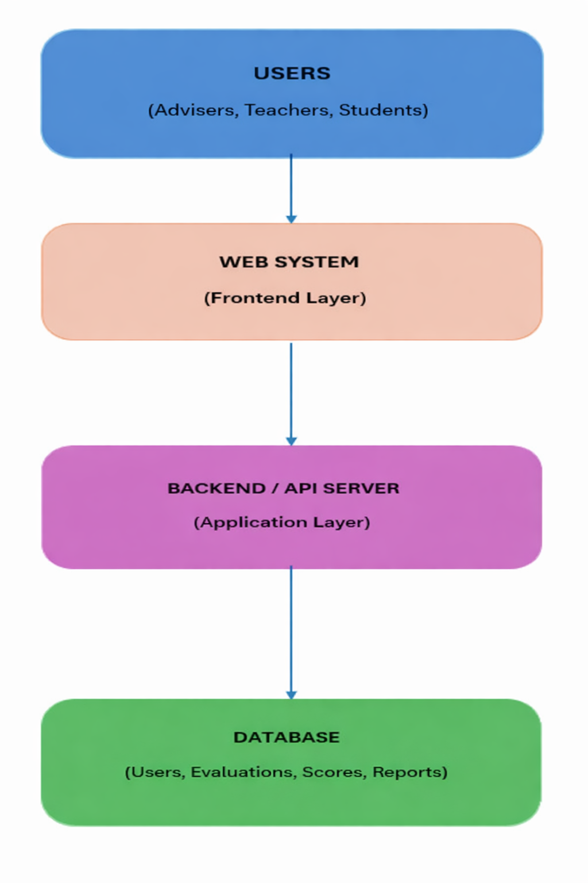

Detailed Design

Module 1

1.1 Transaction name: Class Creation
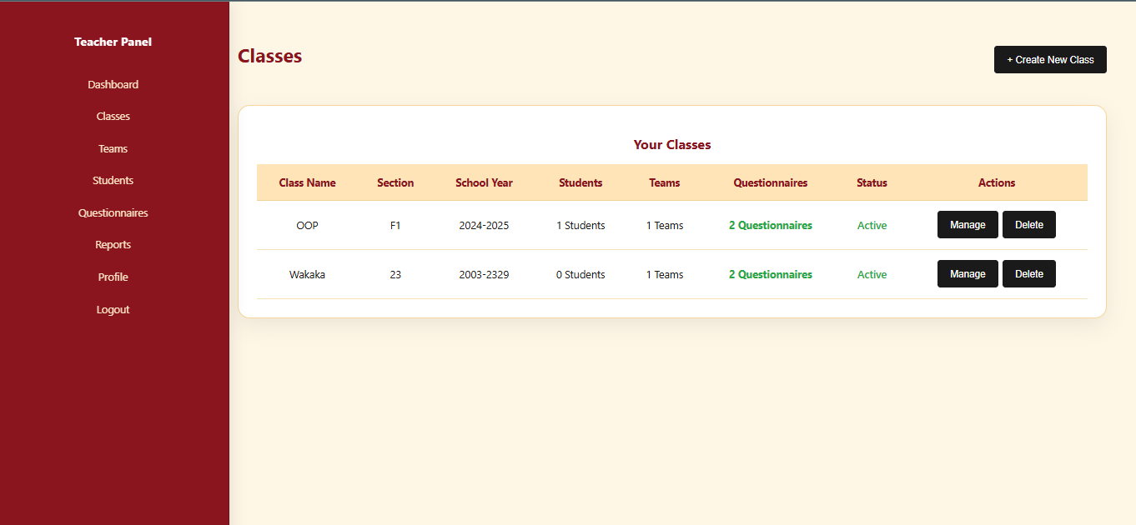
The Class Creation transaction is implemented in the teacher dashboard Classes page (frontend/src/pages/DashboardTeacher/Classes.js).
Main screen:
- Displays a table of classes created by the logged-in teacher, with columns: Class Name, Section, School Year, Students (count), Teams (count), Questionnaires (count), Status (Active/Inactive), Actions.
- Above the table, there is a "+ Create New Class" button.
- Each row has Manage and Delete buttons.
Create New Class modal:
- Opened by the "+ Create New Class" button.
- Form fields:
- Class Name (required, e.g., "IT 3310")
- Section (optional, e.g., "A")
- School Year (required, e.g., "2024-2025")
- Description (optional, textarea)
- Active (checkbox, defaults to checked)
- On submit, the frontend gets the logged-in teacher's ID from localStorage, includes it as teacherId in the request, and calls classAPI.createClass() to create the class.
- Cancel closes the modal without saving.

Frontend Components

Component Name | Description and Purpose | Component Type / File
Classes | Page-level React component for teachers to view, create, and manage classes. Loads classes via classAPI.getAllClasses() and filters by the logged-in teacher's ID. Provides the "Create New Class" modal and handles class creation by calling classAPI.createClass() with class data including teacherId from localStorage. | React functional component using hooks (useState, useEffect), located at frontend/src/pages/DashboardTeacher/Classes.js
TeacherSidebar | Sidebar navigation component for the teacher dashboard, providing consistent layout and navigation while performing Class Creation tasks. | React functional component, imported from frontend/src/components/Sidebar/TeacherSidebar.js
classAPI (from services/api.js) | API helper module that provides functions for class operations: getAllClasses() to fetch all classes, and createClass(classData) to create a new class. Used by the Classes component to communicate with the backend. | JavaScript API helper/service module providing HTTP request functions used by React components
Back-end Components

Component Name | Description and Purpose | Component Type / File
SchoolClassController | REST controller that exposes endpoints under /api/classes for class management: GET /api/classes (list all classes), GET /api/classes/{id} (get class by ID), GET /api/classes/teacher/{teacherId} (get classes by teacher), POST /api/classes (create class), PUT /api/classes/{id} (update class), and DELETE /api/classes/{id} (delete class). Delegates business logic to SchoolClassService and returns SchoolClass entities or error/success responses. | Spring Boot REST controller (@RestController, @RequestMapping("/api/classes")) in backend/src/main/java/group9/advisor_eval_system/controller/SchoolClassController.java
SchoolClassService | Service class that implements business logic for class creation: createClass(SchoolClass schoolClass) validates that a teacher is assigned (either from the request's teacherId or finds the first available teacher), verifies the user has role TEACHER, and saves the class using SchoolClassRepository. | Spring service class (@Service) in backend/src/main/java/group9/advisor_eval_system/service/SchoolClassService.java
SchoolClassRepository | JPA repository interface that provides data access for SchoolClass entities. Includes standard CRUD operations from JpaRepository and custom queries: findByTeacherId(Long teacherId) to get classes by teacher, findByIsActiveTrue() to get active classes, and findByTeacher(User teacher) to get classes by teacher entity. | Spring Data JPA repository interface (extends JpaRepository<SchoolClass, Long>) in backend/src/main/java/group9/advisor_eval_system/repository/SchoolClassRepository.java
SchoolClass | Entity class representing a school class with attributes: id, name, section, schoolYear, description, isActive, createdAt, updatedAt. Includes JSON helper property teacherId for API serialization. Relationships: many-to-one with User as teacher, one-to-many with Team, and many-to-many with Student (via student_classes join table). | JPA entity class (@Entity, @Table(name = "classes")) in backend/src/main/java/group9/advisor_eval_system/entity/SchoolClass.java
UserRepository | JPA repository used by SchoolClassService to load and validate User entities when creating classes (to verify the teacher exists and has the correct role). | Spring Data JPA repository interface in backend/src/main/java/group9/advisor_eval_system/repository/UserRepository.java

- Object-Oriented Components

Class Diagram
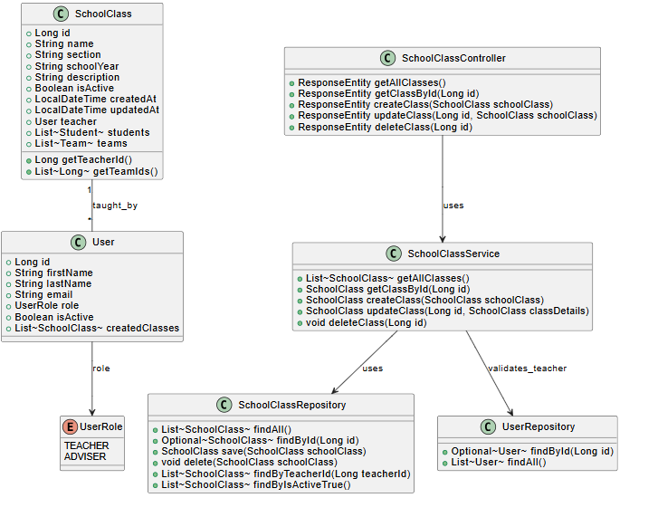

Sequence Diagram
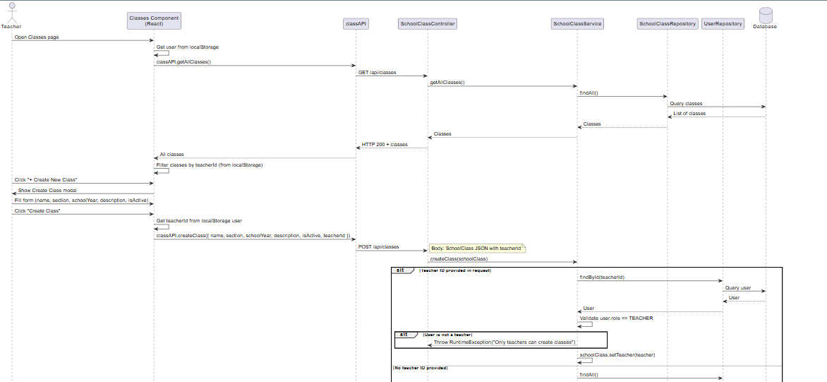
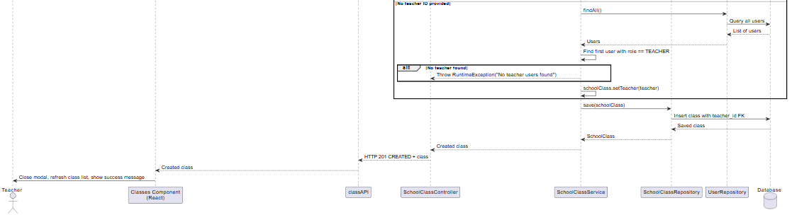

ERD or schema
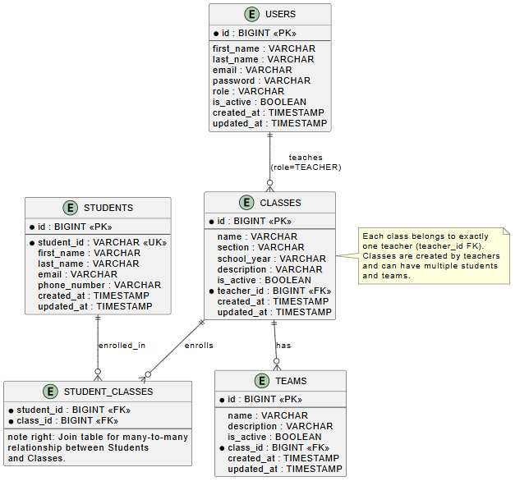

1.2 Transaction name: Student Management (Add / Edit / Remove)

User Interface Design
The Student Management (Add / Edit / Remove) transaction is implemented in the teacher dashboard Student page (frontend/src/pages/DashboardTeacher/Student.js).
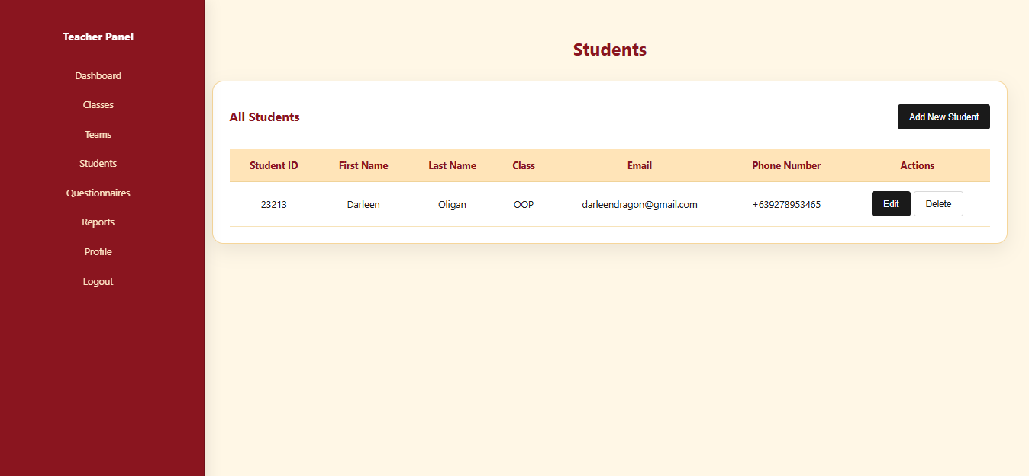
- Main screen
- Displays a table of all students with columns: Student ID, First Name, Last Name, Class, Email, Phone Number, Actions.
- Above the table, there is an “Add New Student” button.
- Each row has Edit and Delete buttons under Actions.
- The Class column shows the list of classes (classIds) a student belongs to, resolved to class names using loaded class data.
- Add/Edit Student modal
- Opened by “Add New Student” (add mode) or “Edit” in a row (edit mode).
- Form fields:
- Classes (multi-select; required, uses classIds to assign the student to one or more SchoolClass records).
- Student ID (required, unique business identifier like 2021-12345).
- First Name (required).
- Last Name (required).
- Email (optional).
- Phone Number (optional).
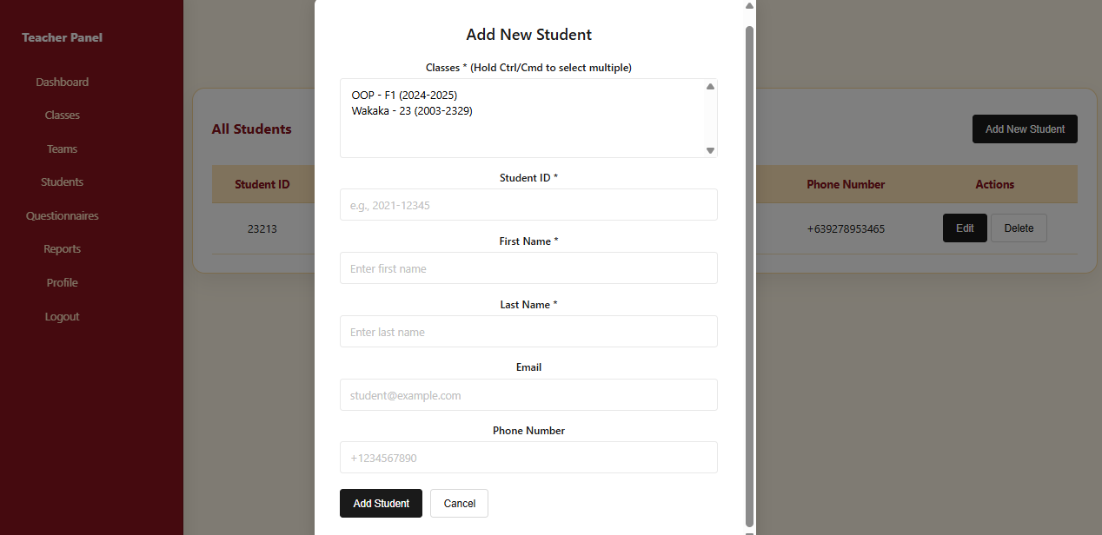
- On submit:
- If adding, calls the backend to create a new student.
- If editing, calls the backend to update the existing student (including class assignments).
- Cancel closes the modal without saving.
- Delete flow
- Clicking Delete prompts a confirmation dialog.
- On confirm, the frontend calls the delete API; on success, the list is refreshed and a success message is shown.

Frontend Components
Component Name | Description and Purpose | Component Type / File
Student | Page-level component for Student Management. Lists all students, provides UI to add, edit, and remove students. Loads students via studentAPI.getAllStudents(), loads classes via classAPI.getAllClasses(), displays data in a table, and manages add/edit modals and delete confirmations. | React functional component using hooks (useState, useEffect); frontend/src/pages/DashboardTeacher/Student.js
TeacherSidebar | Sidebar navigation component for the teacher dashboard, providing consistent layout and navigation while performing Team Formation tasks. | React functional component; frontend/src/components/Sidebar/TeacherSidebar.js
studentAPI, classAPI | studentAPI handles HTTP calls for fetching, creating, updating, and deleting students. classAPI retrieves available classes for assigning class memberships in the UI. | JavaScript API helper/service module; frontend/src/services/api.js

Back-end Components
Component Name | Description and Purpose | Component Type / File
StudentController | Exposes REST endpoints under /api/students for student management: list, retrieve, create, update, and delete students. Delegates logic to the service layer and returns standardized success/error responses. | Spring Boot REST Controller; backend/src/main/java/group9/advisor_eval_system/controller/StudentController.java
StudentService | Implements business logic for managing students. Validates uniqueness of studentId, handles updates safely, manages many-to-many relationships with classes and teams, cleans up team membership when class assignments change, and deletes students when requested. | Spring Service (@Service); backend/src/main/java/group9/advisor_eval_system/service/StudentService.java
StudentRepository | Provides data access for Student entities. Inherits CRUD operations from JpaRepository and defines custom queries to enforce studentId uniqueness and retrieve students by class. | Spring Data JPA Repository; backend/src/main/java/group9/advisor_eval_system/repository/StudentRepository.java

  - Class Diagram
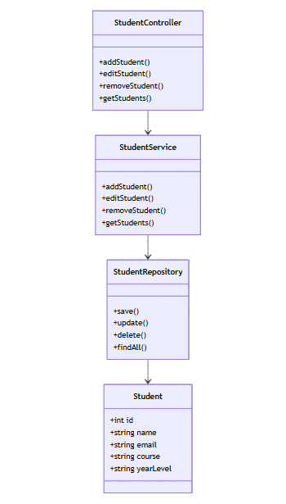

  - Sequence Diagram
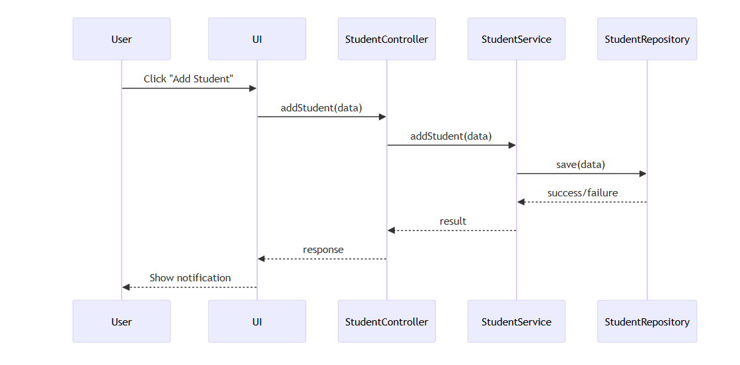
- Data Design
  - ERD or schema
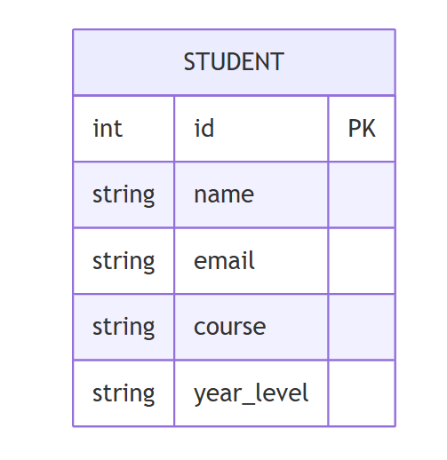

1.3 Transaction name: Team Formation
- User Interface Design
The Team Formation transaction is implemented in the teacher dashboard Teams page (frontend/src/pages/DashboardTeacher/Teams.js).
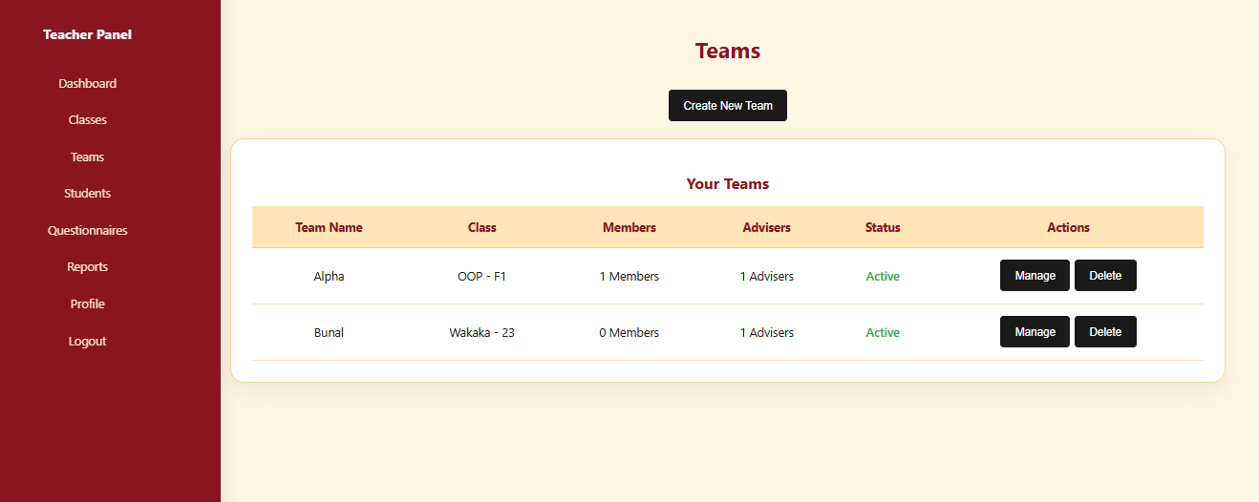
Main screen:
- Table of teams belonging to the logged-in teacher's classes (filtered by teacherId).
- Columns: Team Name, Class, Members (count), Advisers (count), Status (Active/Inactive), Actions.
- "Create New Team" button opens the creation modal.
- Each row has "Manage" (opens management modal) and "Delete" buttons.
Create New Team modal:
- Fields: Team Name (required), Class (required, dropdown of teacher's classes, cannot be changed later), Description (optional).
- On submit, creates a team with empty memberIds and adviserIds.
Manage Team modal:
- Shows selected team name and read-only class information.
- Members section: Lists current members with Remove buttons; "Add Member" dropdown shows available students from the same class not yet in the team.
- Advisers section: Lists current advisers with Remove buttons; "Add Adviser" dropdown shows available adviser users.
- "Save Changes" persists updated memberIds, adviserIds, and isActive to the backend.

Front-end component(s)
Component Name | Description and Purpose | Component Type / File
Teams | Page-level React component for teachers to view, create, and manage project teams for their classes. Loads classes, students, and advisers; filters teams by the current teacher; provides modals for team creation and member/adviser assignment. Handles team CRUD operations via teamAPI. | React functional component using hooks (useState, useEffect), located at frontend/src/pages/DashboardTeacher/Teams.js
TeacherSidebar | Sidebar navigation component for the teacher dashboard, providing consistent layout and navigation while performing Team Formation tasks. | React functional component, imported from frontend/src/components/Sidebar/TeacherSidebar.js
teamAPI (from services/api.js) | API helper module that provides functions for team operations: getAllTeams(), createTeam(teamData), updateTeam(id, teamData), and deleteTeam(id). Used by the Teams component to communicate with the backend. | JavaScript API helper/service module providing HTTP request functions used by React components
classAPI (from services/api.js) | API helper module that retrieves the list of classes so the UI can display and select classes when creating teams. | JavaScript API helper/service module
studentAPI (from services/api.js) | API helper module that retrieves the list of students so the UI can display and select students when adding members to teams. | JavaScript API helper/service module
authAPI (from services/api.js) | API helper module that provides getAllUsers() to fetch all users, which is then filtered to get advisers for team assignment. | JavaScript API helper/service module

Back-end component(s)
Component Name | Description and Purpose | Component Type / File
TeamController | REST controller that exposes endpoints under /api/teams for team management: GET /api/teams (list all teams), GET /api/teams/{id} (get team by ID), GET /api/teams/class/{classId} (get teams by class), POST /api/teams (create team), PUT /api/teams/{id} (update team including members/advisers), and DELETE /api/teams/{id} (delete team). Delegates business logic to TeamService and returns Team entities or error/success responses. | Spring Boot REST controller (@RestController, @RequestMapping("/api/teams")) in backend/src/main/java/group9/advisor_eval_system/controller/TeamController.java
TeamService | Service class that implements business logic for team formation: validates that a team is assigned to an existing SchoolClass when created; ensures a student can only be in one team per class when updating members (validates against existing teams); ensures advisers are existing users with role ADVISER before assignment; manages many-to-many relationships between students, teams, and advisers. | Spring service class (@Service) in backend/src/main/java/group9/advisor_eval_system/service/TeamService.java
TeamRepository | JPA repository interface that provides data access for Team entities. Includes standard CRUD operations from JpaRepository and custom queries: findBySchoolClassId(Long classId) to get teams by class, and findByIsActiveTrue() to get active teams. | Spring Data JPA repository interface (extends JpaRepository<Team, Long>) in backend/src/main/java/group9/advisor_eval_system/repository/TeamRepository.java
Team | Entity class representing a project team with attributes: id, name, description, isActive, createdAt, updatedAt. Includes JSON helper properties (classId, memberIds, adviserIds) for API serialization. Relationships: many-to-one with SchoolClass, many-to-many with Student (via student_teams join table), and many-to-many with User as advisers (via team_advisers join table). | JPA entity class (@Entity, @Table(name = "teams")) in backend/src/main/java/group9/advisor_eval_system/entity/Team.java
SchoolClassRepository | JPA repository used by TeamService to load and validate SchoolClass entities when creating teams. | Spring Data JPA repository interface in backend/src/main/java/group9/advisor_eval_system/repository/SchoolClassRepository.java
StudentRepository | JPA repository used by TeamService to load students when assigning members to teams and to save student-team relationships (since Student is the owning side of the many-to-many relationship). | Spring Data JPA repository interface in backend/src/main/java/group9/advisor_eval_system/repository/StudentRepository.java
UserRepository | JPA repository used by TeamService to load adviser users by ID and validate their roles when assigning advisers to teams. | Spring Data JPA repository interface in backend/src/main/java/group9/advisor_eval_system/repository/UserRepository.java

Object-Oriented Components

Class Diagram
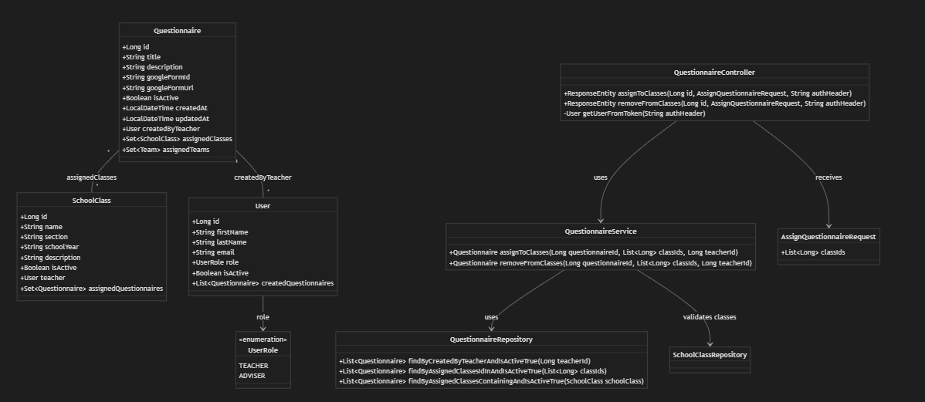
Sequence Diagram
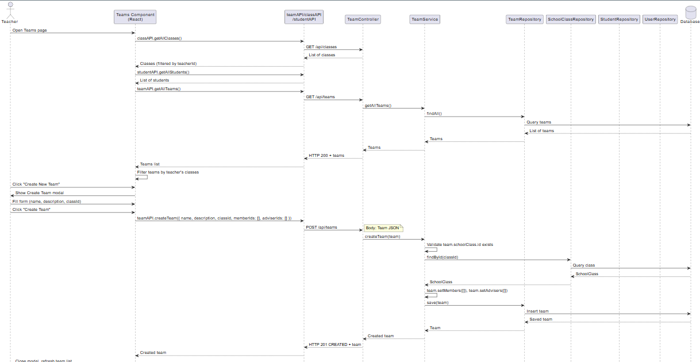
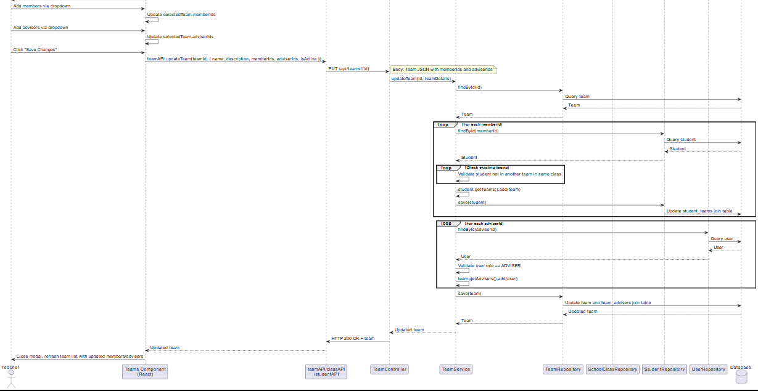

ERD
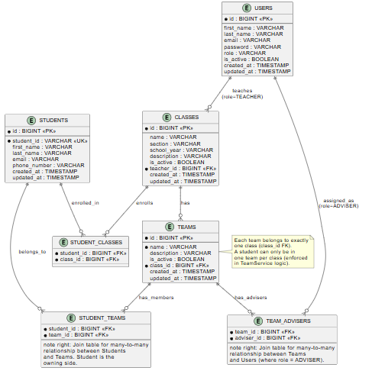

1.4 Transaction name: Adviser Assignment
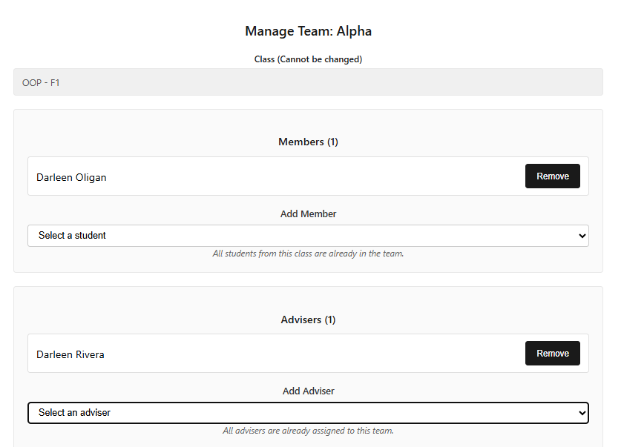

- User Interface Design
- Adviser Assignment happens inside the Manage Team modal on the Teams page (frontend/src/pages/DashboardTeacher/Teams.js).
- When the teacher clicks Manage on a team, the modal shows:
- A read‑only Class field (team’s class).
- An Advisers section listing current advisers (selectedTeam.adviserIds) with a Remove button per adviser.
- An “Add Adviser” dropdown that lists available advisers (from authAPI.getAllUsers() filtered where role === 'ADVISER' and not yet assigned).
- Save Changes button that persists adviser assignments along with other team updates using teamAPI.updateTeam.

Component Name | Description and Purpose | Component Type / File
Teams | Provides the UI for assigning and removing advisers to/from teams. Loads advisers using authAPI.getAllUsers(), filters users with role ADVISER, displays them in the Manage Team modal, and updates selectedTeam.adviserIds when advisers are added or removed before sending data to the backend. | React functional component using hooks (useState, useEffect); frontend/src/pages/DashboardTeacher/Teams.js
TeacherSidebar | Provides the teacher dashboard layout and navigation while the teacher is performing adviser assignment on teams. | React functional component; frontend/src/components/Sidebar/TeacherSidebar.js
teamAPI, authAPI | authAPI.getAllUsers() loads all users so the UI can filter advisers (role === 'ADVISER'). teamAPI.updateTeam(id, payload) sends updated adviser assignments (adviserIds) along with other team data to the backend. | JavaScript API helper/service modules; frontend/src/services/api.js
Front-end ComponentsBack-end Components

Component Name | Description and Purpose | Component Type / File
TeamController | Exposes REST endpoints under /api/teams. For adviser assignment, it handles PUT /api/teams/{id} requests containing adviserIds in the request body and forwards them to TeamService.updateTeam. | Spring Boot REST Controller; backend/src/main/java/group9/advisor_eval_system/controller/TeamController.java
TeamService | Implements business rules for adviser assignment in updateTeam(Long id, Team teamDetails). Resolves adviser IDs to User entities via UserRepository, validates that each user has role ADVISER, updates the many-to-many adviser relationship, and saves the team using TeamRepository. | Spring Service; backend/src/main/java/group9/advisor_eval_system/service/TeamService.java
TeamRepository | Handles persistence and retrieval of Team entities, including adviser relationships, using JPA operations. | Spring Data JPA Repository; backend/src/main/java/group9/advisor_eval_system/repository/TeamRepository.java
UserRepository | Used by TeamService to retrieve adviser users by ID and validate their roles. | Spring Data JPA Repository; backend/src/main/java/group9/advisor_eval_system/repository/UserRepository.java

Object-Oriented Components

  - Class Diagram
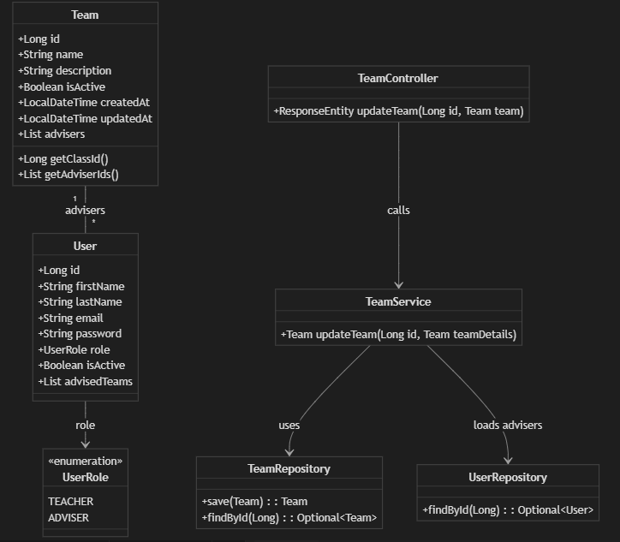

Sequence Diagram
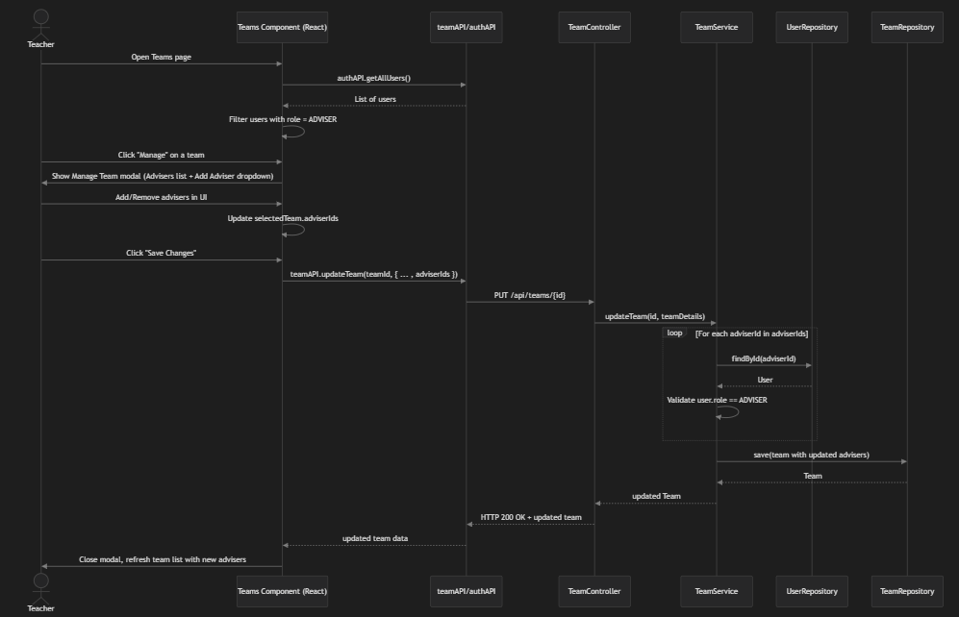

- Data Design
  - ERD or schema
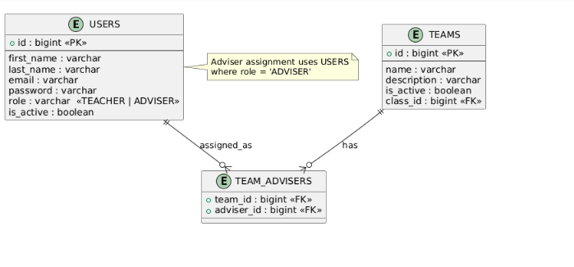

1.5 Transaction Name: Questionnaire Assignment
The Questionnaire Assignment transaction is implemented in two places:
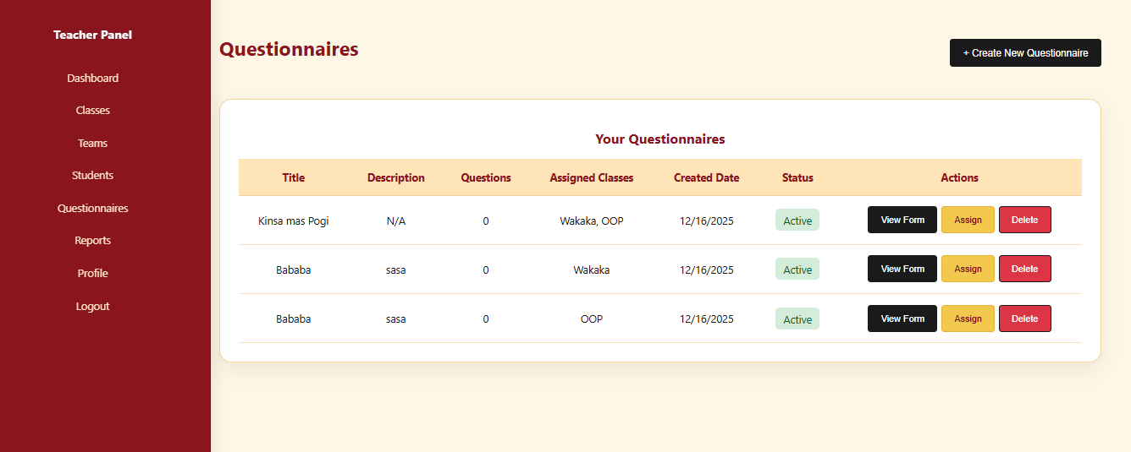
- Questionnaires Page (frontend/src/pages/DashboardTeacher/Questionnaires.js):
- Main screen: Table of questionnaires with columns: Title, Description, Questions, Assigned Classes, Created Date, Status, Actions.
- Each row has "Assign" button that opens the "Assign Questionnaire to Classes" modal.
- Assign to Classes Modal:
- Shows the questionnaire title.
- Displays a scrollable list of classes (teacher's classes) with checkboxes.
- Teacher selects one or more classes.
- "Assign to Selected Classes" button submits the assignment.
- Cancel closes the modal.
Classes Page (frontend/src/pages/DashboardTeacher/Classes.js):
- When viewing a specific class, shows a list of assigned questionnaires.
- "Add Questionnaire" button opens a modal to select and assign a questionnaire to that class.
- Each assigned questionnaire has a Remove button to unassign it from the class.
Front-end component(s)

Component Name | Description and purpose | Component type or format
Questionnaires | Page-level React component that displays all questionnaires created by the teacher and provides the "Assign to Classes" modal. Loads questionnaires via questionnaireAPI.getAllQuestionnaires(), loads classes via classAPI.getAllClasses(), and handles assignment by calling questionnaireAPI.assignToClasses(questionnaireId, classIds). | React functional component using hooks (useState, useEffect), located at frontend/src/pages/DashboardTeacher/Questionnaires.js
Classes | Page-level React component that shows class details and allows adding/removing questionnaires to/from a specific class. Uses questionnaireAPI.assignToClasses() to add and questionnaireAPI.unassignFromClasses() to remove questionnaires from a class. | React functional component using hooks, located at frontend/src/pages/DashboardTeacher/Classes.js
TeacherSidebar | Sidebar navigation component for the teacher dashboard, providing consistent layout and navigation while performing Questionnaire Assignment tasks. | React functional component, imported from frontend/src/components/Sidebar/TeacherSidebar.js
questionnaireAPI (from services/api.js) | API helper module that provides functions for questionnaire operations: getAllQuestionnaires(), getQuestionnairesByClass(classId), assignToClasses(questionnaireId, classIds), and unassignFromClasses(questionnaireId, classIds). Used by both Questionnaires and Classes components. | JavaScript API helper/service module providing HTTP request functions used by React components
classAPI (from services/api.js) | API helper module that retrieves the list of classes so the UI can display and select classes for questionnaire assignment. | JavaScript API helper/service module

Back-end Components

Component Name | Description and purpose | Component type or format
QuestionnaireController | REST controller that exposes endpoints under /api/questionnaires for questionnaire assignment: POST /api/questionnaires/{id}/assign (assigns questionnaire to classes) and POST /api/questionnaires/{id}/unassign (removes questionnaire from classes). Extracts the teacher user from JWT token, validates that only teachers can assign, and delegates to QuestionnaireService. | Spring Boot REST controller (@RestController, @RequestMapping("/api/questionnaires")) in backend/src/main/java/group9/advisor_eval_system/controller/QuestionnaireController.java
QuestionnaireService | REST controller that exposes endpoints under /api/questionnaires for questionnaire assignment: POST /api/questionnaires/{id}/assign (assigns questionnaire to classes) and POST /api/questionnaires/{id}/unassign (removes questionnaire from classes). Extracts the teacher user from JWT token, validates that only teachers can assign, and delegates to QuestionnaireService. | Spring service class (@Service) in backend/src/main/java/group9/advisor_eval_system/service/QuestionnaireService.java
QuestionnaireRepository | JPA repository interface that provides data access for Questionnaire entities. Includes custom queries: findByCreatedByTeacherAndIsActiveTrue() to get teacher's questionnaires, findByAssignedClassesIdInAndIsActiveTrue() to get questionnaires assigned to specific classes, and findByAssignedClassesContainingAndIsActiveTrue() to get questionnaires for a class. | Spring Data JPA repository interface (extends JpaRepository<Questionnaire, Long>) in backend/src/main/java/group9/advisor_eval_system/repository/QuestionnaireRepository.java
SchoolClassRepository | JPA repository used by QuestionnaireService to load and validate SchoolClass entities when assigning questionnaires to classes. | Spring Data JPA repository interface in backend/src/main/java/group9/advisor_eval_system/repository/SchoolClassRepository.java
Questionnaire | Entity class representing a questionnaire with attributes: id, title, description, googleFormId, googleFormUrl, isActive, and relationships: many-to-one to User (createdByTeacher), many-to-many to SchoolClass (assignedClasses via join table class_questionnaires), and many-to-many to Team (assignedTeams). | JPA entity class (@Entity, @Table(name = "questionnaires")) in backend/src/main/java/group9/advisor_eval_system/entity/Questionnaire.java
AssignQuestionnaireRequest | DTO class used to receive assignment requests from the frontend. Contains List<Long> classIds field with validation (@NotEmpty). | Data Transfer Object (DTO) class in backend/src/main/java/group9/advisor_eval_system/dto/AssignQuestionnaireRequest.java

- Object-Oriented Components
  - Class Diagram
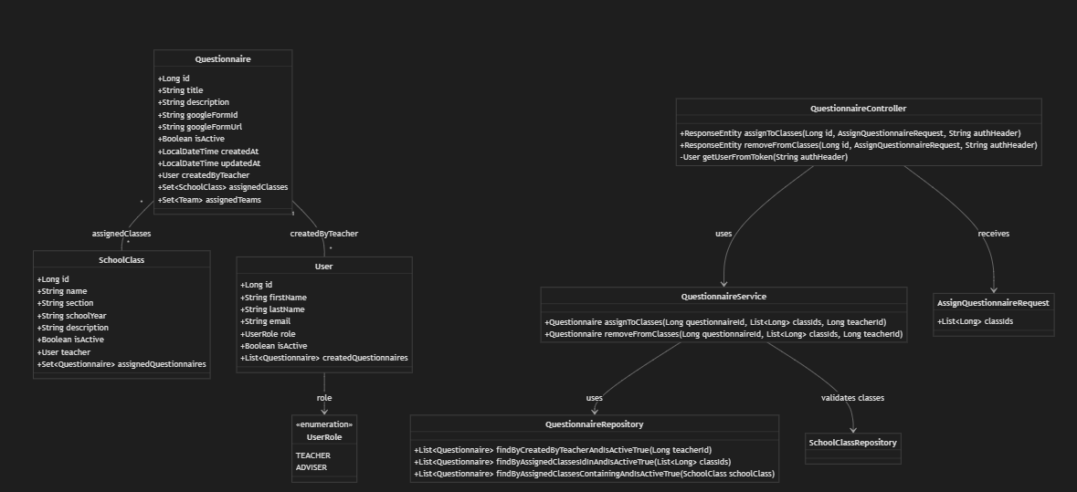
  - Sequence Diagram
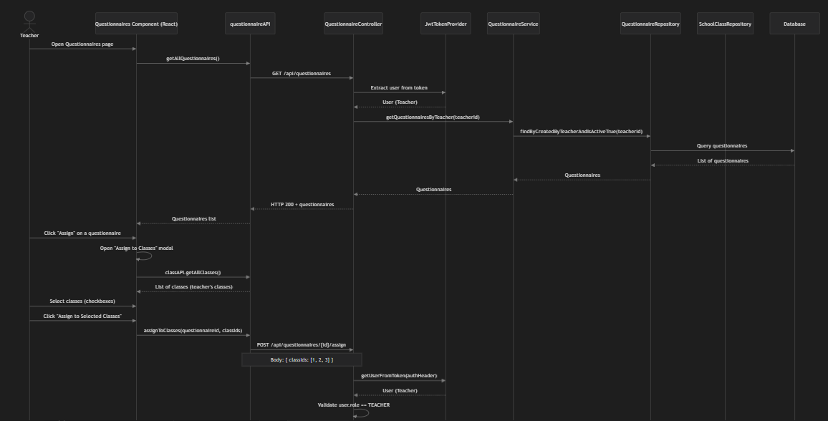
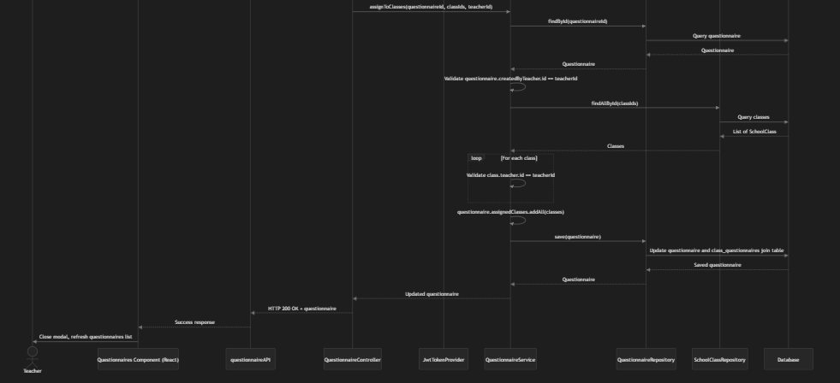

- Data Design

  - ERD or schema
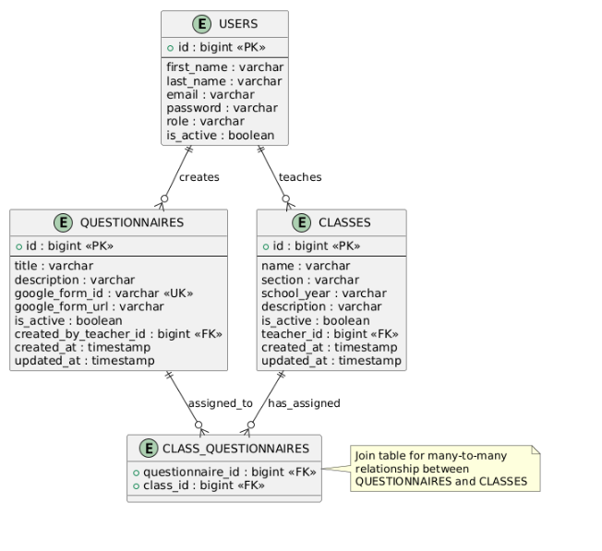

Module 2 - Adviser Evaluation Module

2.1Transaction name: Adviser Dashboard
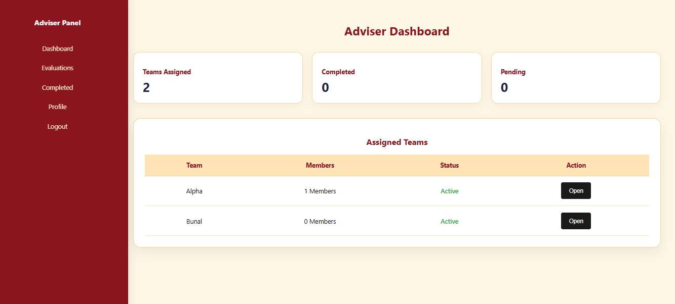
The Adviser Dashboard transaction is implemented in the adviser dashboard page (frontend/src/pages/DashboardAdviser/Adviser.js).
Main screen:
- Displays "Adviser Dashboard" heading centered at the top.
- Summary Cards Row: Three summary cards showing:
- Teams Assigned: Count of teams assigned to the logged-in adviser
- Completed: Count of completed evaluations (currently hardcoded to "0")
- Pending: Count of pending evaluations (currently hardcoded to "0")
Assigned Teams Section: A white card containing:
- "Assigned Teams" heading
- A table with columns: Team, Members (count), Status (Active/Inactive with color coding), Action
- Each row has an "Open" button that navigates to /adviser/evaluations
- Shows "Loading..." while fetching data
- Shows "No assigned teams found." if no teams are assigned
- Error Message: Displays error messages if data loading fails
Navigation:
- Left sidebar (AdviserSidebar) provides navigation to Dashboard, Evaluations, Completed, Profile, and Logout

Front-end components
Component Name | Description and purpose | Component type or format
Adviser | Page-level React component that displays the adviser dashboard with summary statistics and a list of teams assigned to the logged-in adviser. Loads teams via teamAPI.getAllTeams(), filters teams where the adviser's ID is in adviserIds, displays summary cards, and shows assigned teams in a table. Handles loading states and error display. | React functional component using hooks (useState, useEffect, useMemo), located at frontend/src/pages/DashboardAdviser/Adviser.js
AdviserSidebar | Sidebar navigation component for the adviser dashboard, providing consistent layout and navigation while viewing the dashboard. Contains links to Dashboard, Evaluations, Completed, Profile, and Logout. | React functional component, imported from frontend/src/components/Sidebar/AdviserSidebar.js
SummaryCard | Reusable card component that displays a title and value for dashboard statistics. Used to show "Teams Assigned", "Completed", and "Pending" metrics. | React functional component, imported from frontend/src/components/Cards/SummaryCard.js
teamAPI (from services/api.js) | API helper module that provides getAllTeams() function to fetch all teams from the backend. Used by the Adviser component to retrieve teams, which are then filtered client-side to show only teams assigned to the current adviser. | JavaScript API helper/service module providing HTTP request functions used by React components

Back-end component(s)
Component Name | Description and purpose | Component type or format
TeamController | REST controller that exposes endpoints under /api/teams for team management. For the Adviser Dashboard, the GET /api/teams endpoint returns all teams (including their adviserIds array), which the frontend then filters to show only teams assigned to the logged-in adviser. | Spring Boot REST controller (@RestController, @RequestMapping("/api/teams")) in backend/src/main/java/group9/advisor_eval_system/controller/TeamController.java
TeamService | Service class that implements business logic for team operations. The getAllTeams() method retrieves all teams from the repository, which are then returned to the controller and ultimately to the frontend for filtering. | Spring service class (@Service) in backend/src/main/java/group9/advisor_eval_system/service/TeamService.java
TeamRepository | JPA repository interface that provides data access for Team entities. The findAll() method retrieves all teams from the database, including their relationships with advisers via the team_advisers join table. | Spring Data JPA repository interface (extends JpaRepository<Team, Long>) in backend/src/main/java/group9/advisor_eval_system/repository/TeamRepository.java
Team | Entity class representing a project team with attributes: id, name, description, isActive, createdAt, updatedAt. Includes JSON helper property adviserIds (exposed via @JsonProperty) that contains the list of adviser user IDs assigned to the team. This property is used by the frontend to filter teams assigned to the logged-in adviser. | JPA entity class (@Entity, @Table(name = "teams")) in backend/src/main/java/group9/advisor_eval_system/entity/Team.java

User

Class Diagram
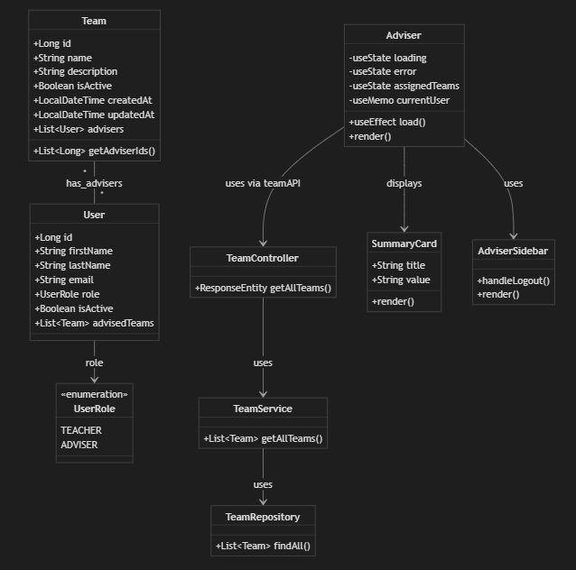

Sequence Diagram
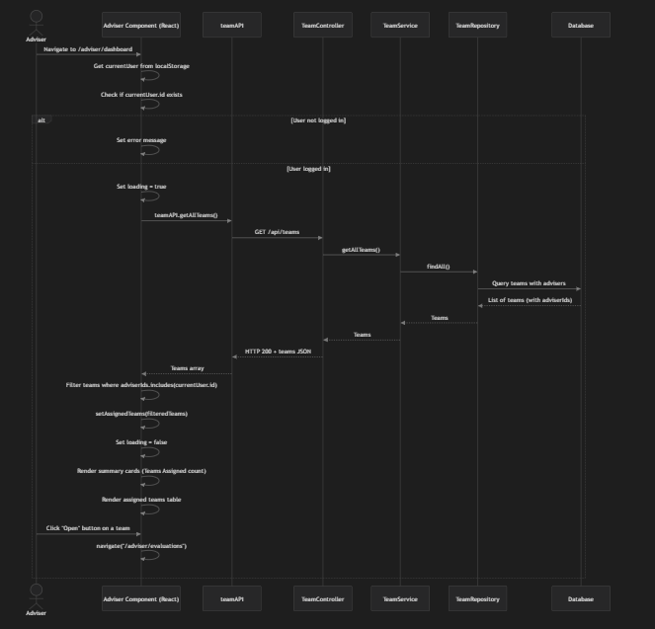

ERD
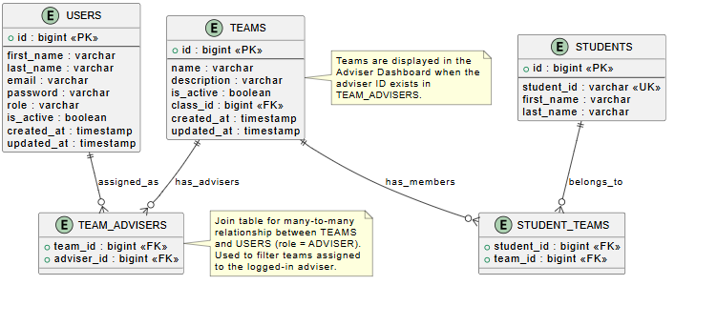

2.2 Transaction name: Evaluation and Scoring

The Evaluation & Scoring transaction is implemented in the adviser dashboard Evaluations page (frontend/src/pages/DashboardAdviser/Evaluations.js).

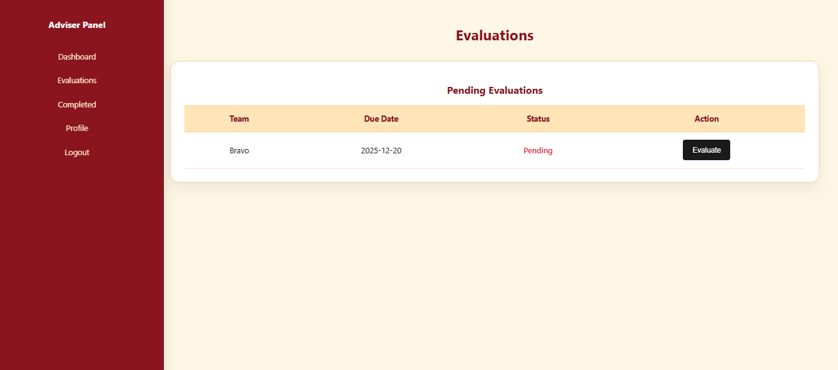

Main screen:
- Displays "Evaluations" heading centered at the top.
- Pending Evaluations Section: A white card containing:
- "Pending Evaluations" heading
- A table with columns: Team, Due Date, Status, Action
- Each row shows a team name, due date, status (e.g., "Pending" in red), and an "Evaluate" button
- Clicking "Evaluate" opens the evaluation form for that team
Evaluation Form (expected functionality based on entity structure):
- Displays questionnaire questions from the assigned questionnaire
- For each question, provides input fields based on question type:
- NUMERIC_SCALE/RATING: Numeric input (within min/max range)
- TEXT: Textarea for text responses
- MULTIPLE_CHOICE: Radio buttons or dropdown with choices
- General Comments field for overall feedback
- Submit Evaluation button to save scores and change status to SUBMITTED
- Save Draft functionality to save progress (status remains IN_PROGRESS)
Navigation:
- Left sidebar (AdviserSidebar) provides navigation to Dashboard, Evaluations, Completed, Profile, and Logout

Front-end component(s)
Component Name | Description and purpose | Component type or format
Evaluations | Page-level React component that displays pending evaluations for teams assigned to the logged-in adviser. Currently shows a static table, but designed to load evaluations via evaluationAPI.getAllEvaluations() and filter by adviser ID and status. Provides "Evaluate" buttons to open evaluation forms for scoring teams. | React functional component, located at frontend/src/pages/DashboardAdviser/Evaluations.js
AdviserSidebar | Sidebar navigation component for the adviser dashboard, providing consistent layout and navigation while viewing the dashboard. Contains links to Dashboard, Evaluations, Completed, Profile, and Logout. | React functional component, imported from frontend/src/components/Sidebar/AdviserSidebar.js
evaluationAPI (from services/api.js) | API helper module that provides functions for evaluation operations: getAllEvaluations() to fetch all evaluations, getEvaluationById(id) to get a specific evaluation, createEvaluation(evaluationData) to create a new evaluation, and submitEvaluation(id, scores) to submit scores for an evaluation. Used by evaluation components to communicate with the backend. | JavaScript API helper/service module providing HTTP request functions used by React components

Backend Components
Component Name | Description and purpose | Component type or format
Evaluation | Entity class representing an evaluation of a team by an adviser using a questionnaire. Attributes: id, generalComments, status (IN_PROGRESS, SUBMITTED, REVIEWED), submittedAt, allowEdit, createdAt, updatedAt. Relationships: many-to-one with Team, many-to-one with User (adviser), many-to-one with Questionnaire, and one-to-many with EvaluationScore (individual question scores). | JPA entity class (@Entity, @Table(name = "evaluations")) in backend/src/main/java/group9/advisor_eval_system/entity/Evaluation.java
EvaluationScore | Entity class representing an individual score/response for a specific questionnaire item within an evaluation. Attributes: id, numericScore (for numeric/rating questions), textResponse (for text questions), createdAt, updatedAt. Relationships: many-to-one with Evaluation and many-to-one with QuestionnaireItem (the question being answered). | JPA entity class (@Entity, @Table(name = "evaluation_scores")) in backend/src/main/java/group9/advisor_eval_system/entity/EvaluationScore.java
EvaluationRepository | JPA repository interface that provides data access for Evaluation entities. Includes custom queries: findByAdviserId(Long adviserId) to get evaluations by adviser, findByTeamId(Long teamId) to get evaluations for a team, findByTeamIdAndAdviserId(Long teamId, Long adviserId) to find a specific evaluation, and findByStatus(EvaluationStatus status) to filter by status. | Spring Data JPA repository interface (extends JpaRepository<Evaluation, Long>) in backend/src/main/java/group9/advisor_eval_system/repository/EvaluationRepository.java
EvaluationScoreRepository | JPA repository interface that provides data access for EvaluationScore entities. Includes custom queries: findByEvaluation(Evaluation evaluation) and findByEvaluationId(Long evaluationId) to get all scores for a specific evaluation. | Spring Data JPA repository interface (extends JpaRepository<EvaluationScore, Long>) in backend/src/main/java/group9/advisor_eval_system/repository/EvaluationScoreRepository.java
QuestionnaireItem | Entity class representing a question within a questionnaire. Attributes: id, questionText, orderIndex, questionType (NUMERIC_SCALE, TEXT, MULTIPLE_CHOICE, RATING), maxScore, minScore, choices (JSON string for multiple choice options). Used by the evaluation form to display questions and validate score inputs. | JPA entity class (@Entity, @Table(name = "questionnaire_items")) in backend/src/main/java/group9/advisor_eval_system/entity/QuestionnaireItem.java

Class Diagram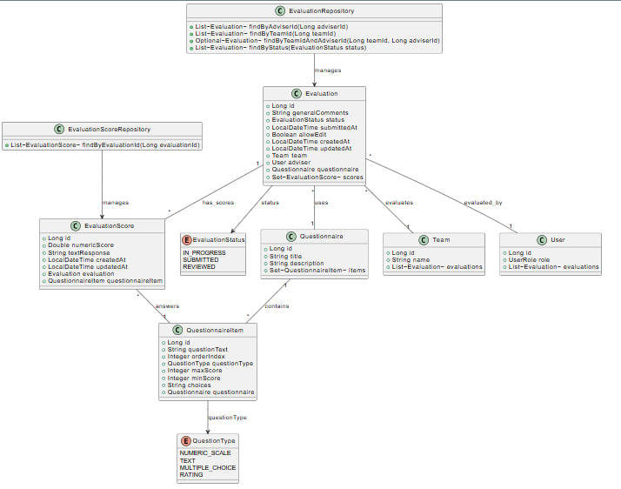

Sequence Diagram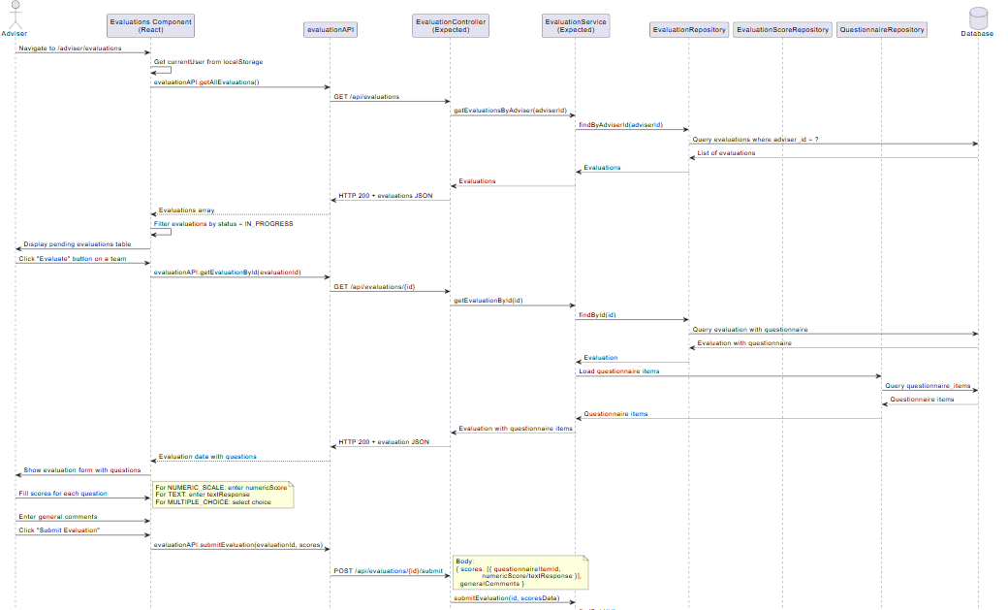
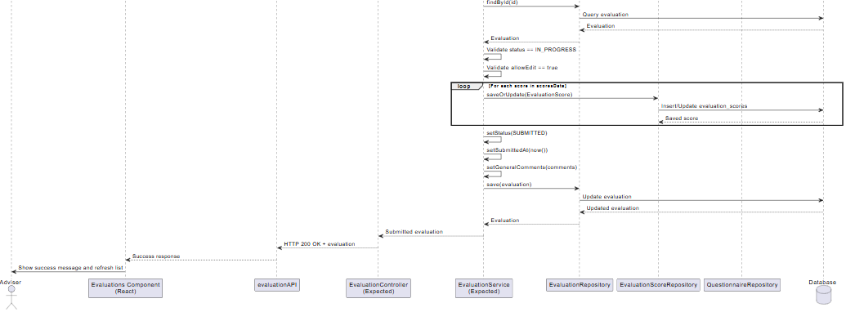
ERD
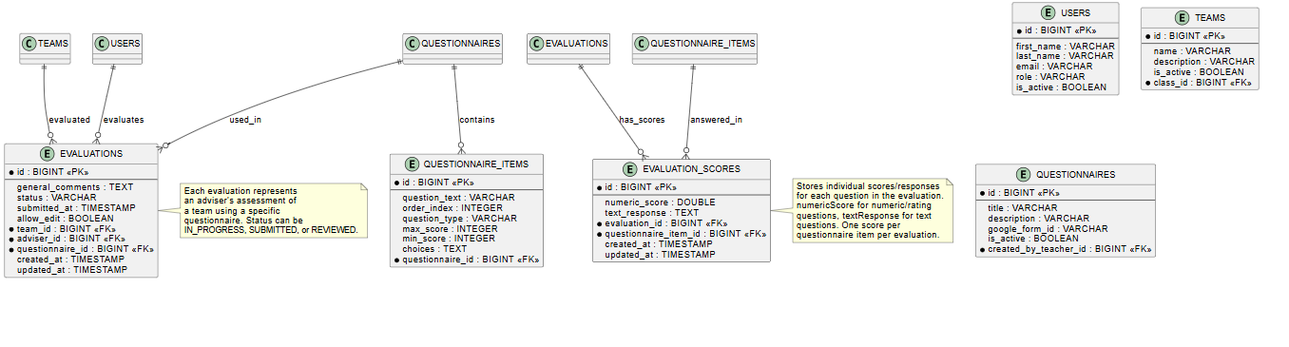

2.3 Transaction Name: Evaluation Tracking

Adviser Dashboard (frontend/src/pages/DashboardAdviser/Adviser.js):
- Summary cards showing "Teams Assigned", "Completed", and "Pending" counts
- Table of assigned teams with status (Active/Inactive)
Evaluations Page (frontend/src/pages/DashboardAdviser/Evaluations.js):
- "Pending Evaluations" section showing teams with status "Pending"
- Table columns: Team, Due Date, Status, Action
- "Evaluate" button to open evaluation form
Completed Page (frontend/src/pages/DashboardAdviser/Completed.js):
- "Completed Evaluations" section showing teams with completed evaluations
- Table columns: Team, Members, Date (submission date), Action
- "View" button to view completed evaluation details
Reports Page (frontend/src/pages/DashboardTeacher/Reports.js):
- "Reports List" section for teachers to view generated reports
- Table columns: Report Name, Date, Status, Action
- "Download" button to download reports

Front-end component(s)

Component Name | Description and purpose | Component type or format
Adviser | Page-level React component that displays the adviser dashboard with summary statistics tracking evaluation status. Shows counts for "Teams Assigned", "Completed", and "Pending" evaluations. Loads teams via teamAPI.getAllTeams() and filters by adviser ID to track which teams have been evaluated. | React functional component using hooks (useState, useEffect, useMemo), located at frontend/src/pages/DashboardAdviser/Adviser.js
Evaluations | Page-level React component that displays pending evaluations for teams assigned to the logged-in adviser. Designed to load evaluations via evaluationAPI.getAllEvaluations() and filter by status = IN_PROGRESS to track which evaluations are still pending. Currently shows static data but structured to display pending evaluations with due dates and status. | React functional component, located at frontend/src/pages/DashboardAdviser/Evaluations.js
Completed | Page-level React component that displays completed evaluations for teams assigned to the logged-in adviser. Designed to load evaluations via evaluationAPI.getAllEvaluations() and filter by status = SUBMITTED or REVIEWED to track completed evaluations. Shows submission dates and provides "View" buttons to review completed evaluations. | React functional component, located at frontend/src/pages/DashboardAdviser/Completed.js
Reports | Page-level React component that displays evaluation reports generated from completed evaluations. Designed to load reports via reportAPI.getAllReports() to track evaluation summaries, performance data, and AI-generated summaries. Provides download functionality for reports. | React functional component, located at frontend/src/pages/DashboardTeacher/Reports.js
AdviserSidebar | Sidebar navigation component for the adviser dashboard, providing navigation to Dashboard, Evaluations, Completed, Profile, and Logout pages for tracking evaluations. | React functional component, imported from frontend/src/components/Sidebar/AdviserSidebar.js
evaluationAPI (from services/api.js) | API helper module that provides functions for evaluation tracking: getAllEvaluations() to fetch all evaluations (can be filtered by status), getEvaluationById(id) to get a specific evaluation for viewing, createEvaluation(evaluationData) to create new evaluations, and submitEvaluation(id, scores) to submit evaluations (changes status to SUBMITTED). | JavaScript API helper/service module providing HTTP request functions used by React components
reportAPI (from services/api.js) | API helper module that provides functions for report tracking: getAllReports() to fetch all reports, getReportById(id) to get a specific report, generateReport(reportData) to generate new reports from evaluations, and downloadReport(id) to download reports. | JavaScript API helper/service module providing HTTP request functions used by React components

Back-end component(s)

Component Name | Description and purpose | Component type or format
Evaluation | Entity class representing an evaluation with status tracking. Attributes: id, generalComments, status (IN_PROGRESS, SUBMITTED, REVIEWED), submittedAt timestamp, allowEdit, createdAt, updatedAt. The status field is used to track evaluation progress and filter evaluations by completion status. Relationships: many-to-one with Team, User (adviser), and Questionnaire; one-to-many with EvaluationScore. | JPA entity class (@Entity, @Table(name = "evaluations")) in backend/src/main/java/group9/advisor_eval_system/entity/Evaluation.java
EvaluationRepository | JPA repository interface that provides data access for Evaluation entities with tracking queries: findByAdviserId(Long adviserId) to get all evaluations by an adviser, findByTeamId(Long teamId) to get all evaluations for a team, findByStatus(EvaluationStatus status) to filter evaluations by status (IN_PROGRESS, SUBMITTED, REVIEWED), and findByTeamIdAndAdviserId(Long teamId, Long adviserId) to find a specific evaluation. Used for tracking evaluation status and filtering completed vs pending evaluations. | Spring Data JPA repository interface (extends JpaRepository<Evaluation, Long>) in backend/src/main/java/group9/advisor_eval_system/repository/EvaluationRepository.java
EvaluationScore | Entity class representing an individual score/response for a questionnaire item within an evaluation. Attributes: id, numericScore, textResponse, createdAt, updatedAt. Used to track detailed scoring data for each question in an evaluation, which can be aggregated for reports. | JPA entity class (@Entity, @Table(name = "evaluation_scores")) in backend/src/main/java/group9/advisor_eval_system/entity/EvaluationScore.java
EvaluationScoreRepository | JPA repository interface that provides data access for EvaluationScore entities. Includes findByEvaluationId(Long evaluationId) to get all scores for a specific evaluation, used for tracking detailed evaluation data and generating reports. | Spring Data JPA repository interface (extends JpaRepository<EvaluationScore, Long>) in backend/src/main/java/group9/advisor_eval_system/repository/EvaluationScoreRepository.java
Report | Entity class representing a generated report from evaluation data. Attributes: id, title, aiSummary (AI-generated summary), performanceData (JSON format with rankings and scores), reportType (CLASS_PERFORMANCE, TEAM_COMPARISON, INDIVIDUAL_TEAM, ADVISER_SUMMARY), generatedAt. Relationships: many-to-one with SchoolClass and User (generated by teacher). Used to track and store evaluation reports for later viewing and download. | JPA entity class (@Entity, @Table(name = "reports")) in backend/src/main/java/group9/advisor_eval_system/entity/Report.java
ReportRepository | JPA repository interface that provides data access for Report entities. Includes findBySchoolClassId(Long classId) to get reports for a specific class, findByReportType(ReportType reportType) to filter reports by type, and findBySchoolClass(SchoolClass schoolClass) to get reports for a class entity. Used for tracking and retrieving generated evaluation reports. | Spring Data JPA repository interface (extends JpaRepository<Report, Long>) in backend/src/main/java/group9/advisor_eval_system/repository/ReportRepository.java

Class Diagram

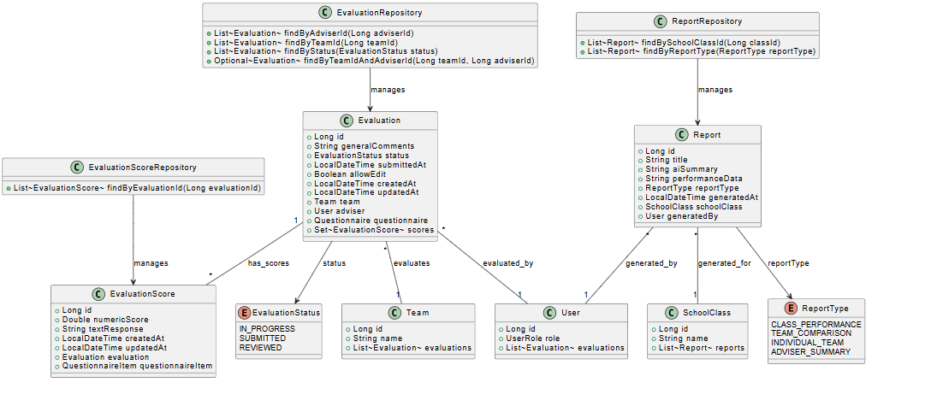

Sequence Diagram
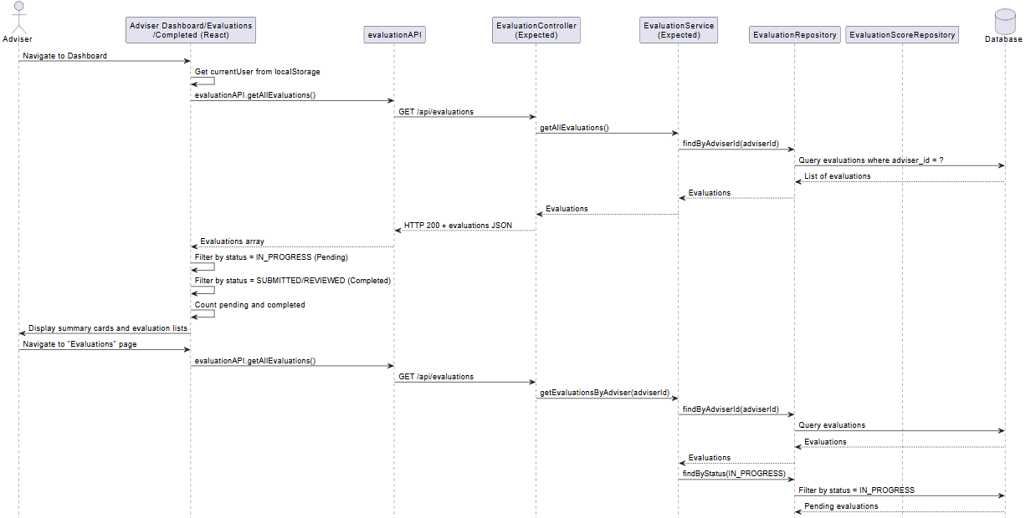
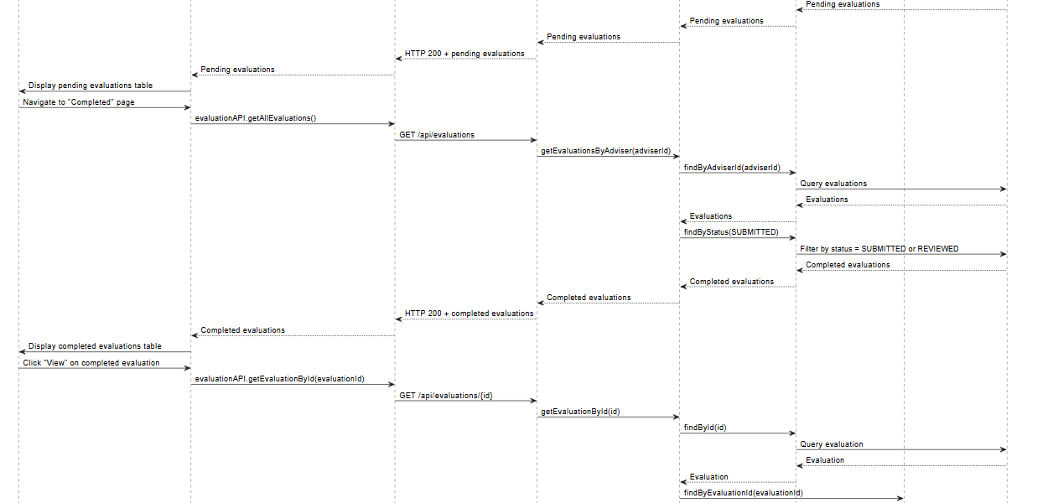
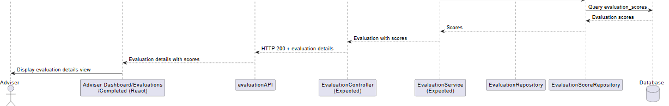

ERD
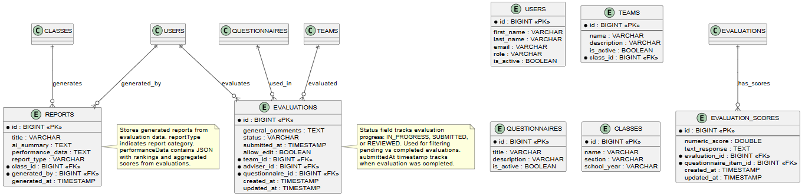

Module 3 - Reporting & AI Summarization Module

3.1 Transaction name: Performance Ranking

- User Interface Design

- Front-end component(s)
Component Name | Description and Purpose | Component Type / Format
Reports.js | Displays rankings and AI summary | React component
Teacher.js | Teacher dashboard layout | React component

- Back-end component(s)

Component Name | Description and Purpose | Component Type / Format
ReportRepository.java | Aggregates evaluation data | Spring Data JPA Repository
EvaluationRepository.java | Provides evaluation data | Spring Data JPA Repository
TeamRepository.java | Retrieves teams per class | Spring Data JPA Repository
Report.java | Entity for report metadata | WJPA Entity

o Class Diagram
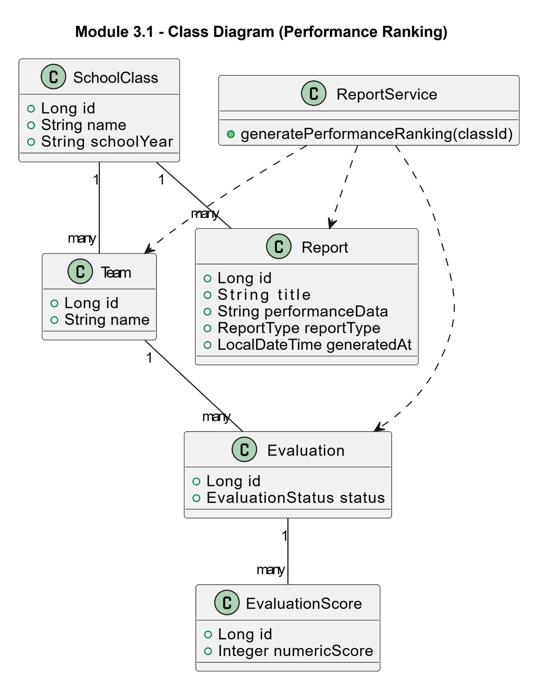

o Sequence Diagram
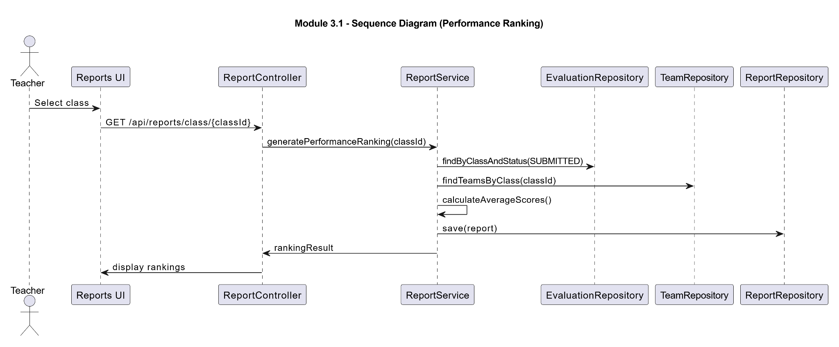

o ERD
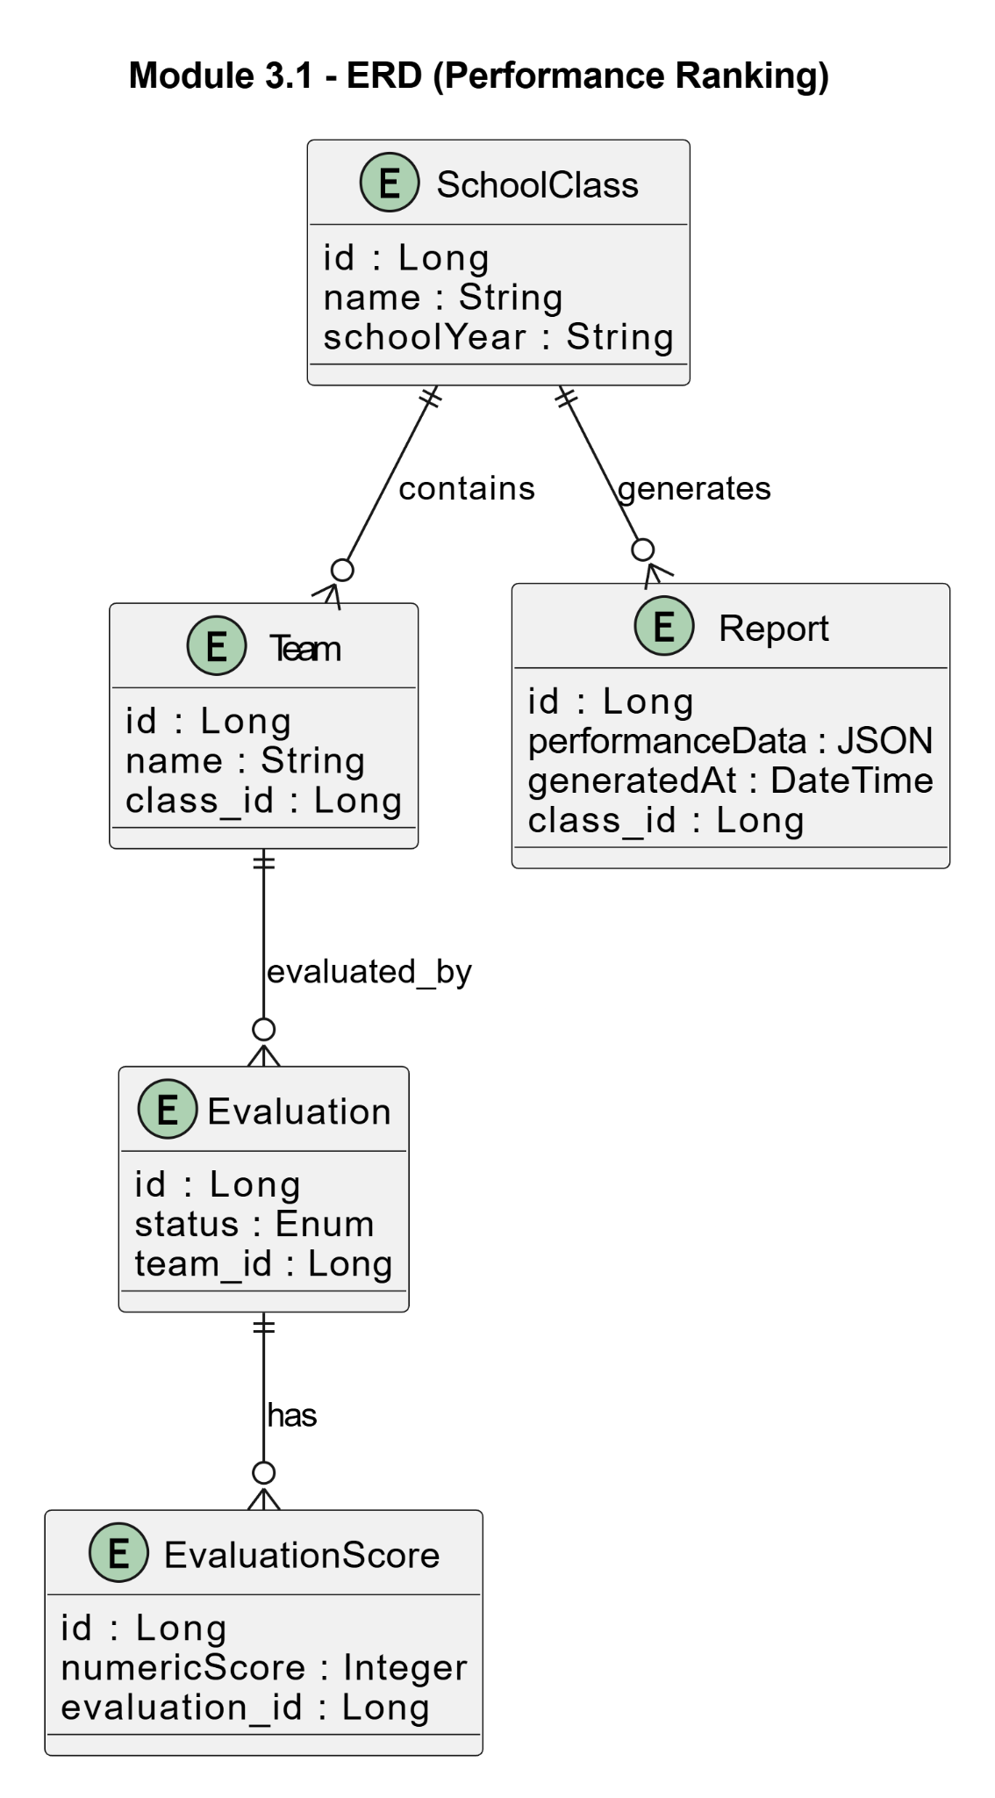

3.2 Transaction name: AI-Assisted Summary

- User Interface Design
- Front-end component(s)
Component Name | Description and Purpose | Component Type / Format
AISummaryPanel | Displays AI-generated summary | React component
reportAPI | Sends request to generate summary | JS API module

- Back-end component(s)

Component Name | Description and Purpose | Component Type / Format
QuestionnaireController.java | Endpoint for AI summary | Spring Boot REST Controller
GoogleFormsService.java | Fetches form responses | Spring Service
QuestionnaireService.java | Links teams to Google Forms | Spring Service
AISummaryService (inside QuestionnaireService) | Calls Gemini/OpenAI | Service logic
Report.java | Stores summary (optional) | JPA Entity

o Class Diagram
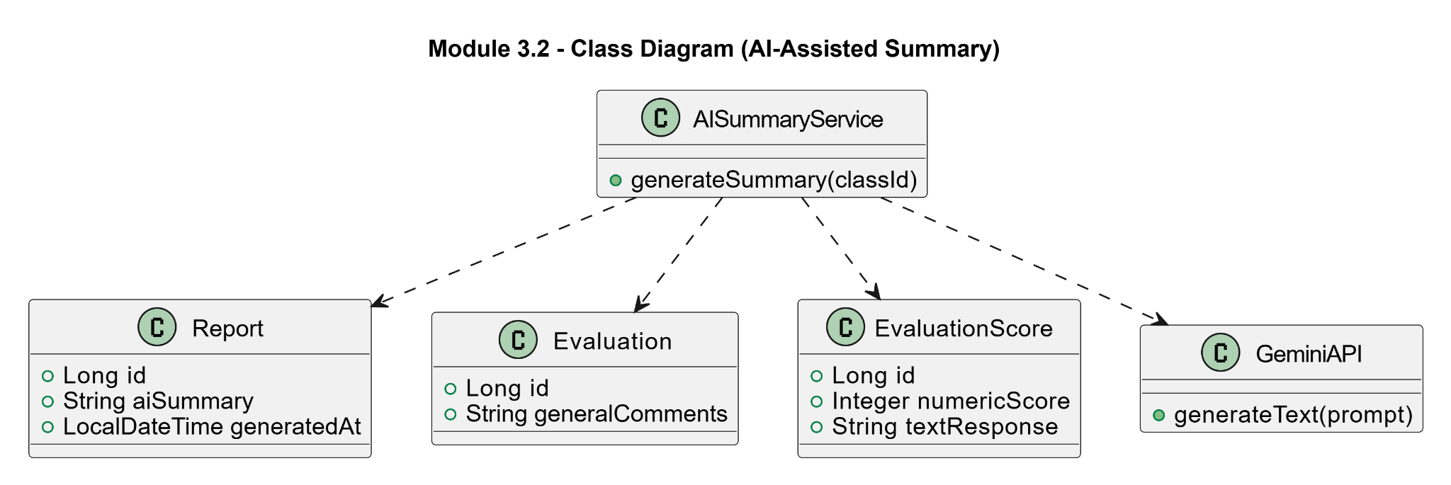

o Sequence Diagram

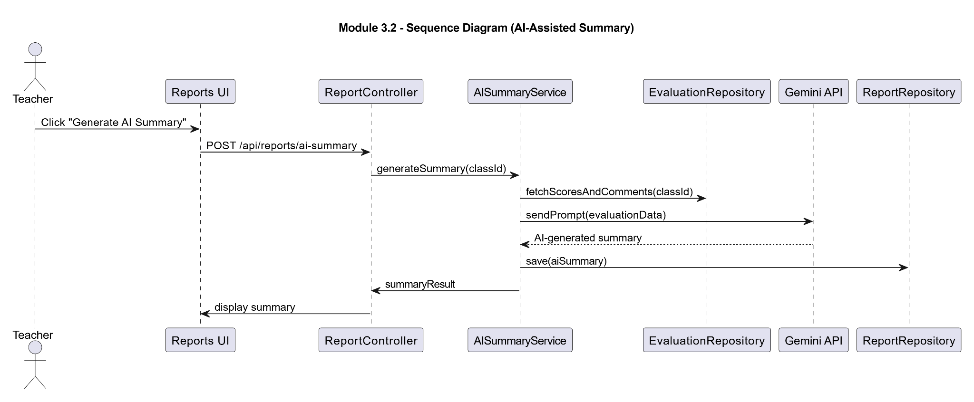

o ERD
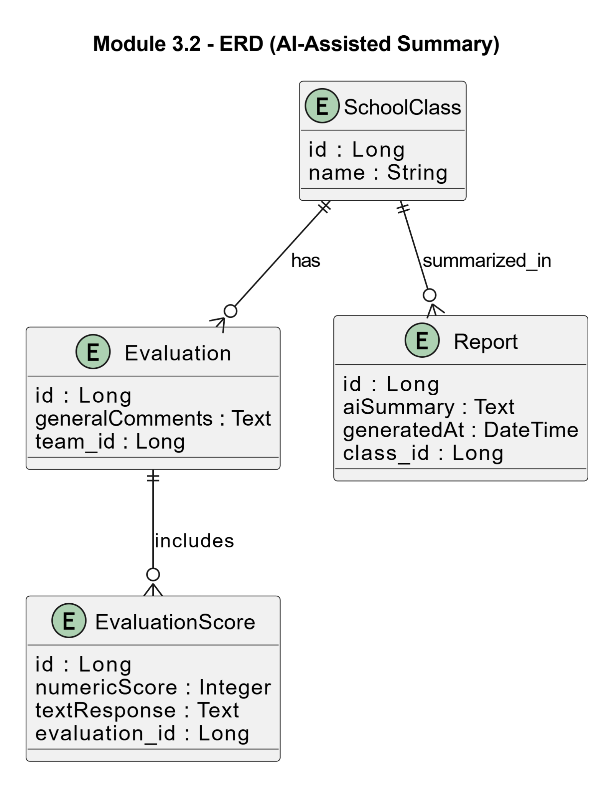

3.3 Transaction: Comment Collection
When the teacher accesses a student's evaluation results, the system automatically retrieves all completed and validated peer evaluation submissions related to that student. The system filters out incomplete entries (null or empty comments) and organizes the qualified comments for AI processing.

- User Interface Design
- Front-end component(s)

Component Name | Description and Purpose | Component Type / Format
TeacherInsightsPanel.jsx | The teacher-facing dashboard panel that triggers comment collection by requesting the AI summary for a specific student. Displays a loading state while the system gathers comments and generates the summary. | React.js Component
summaryService.js | Handles API calls: GET /summaries/student/{studentId}/activity/{actId} to fetch or trigger the full summarization pipeline. | JavaScript Service Module

- Back-end component(s)

Component Name | Description and Purpose | Component Type / Format
SummaryController.java | Receives the teacher's request for a student's AI summary. Triggers the CommentCollectionService and passes the result to SummarizationService. | Spring Boot REST Controller
CommentCollectionService.java | Queries the evaluations and comments tables to retrieve all peer evaluation comments where target_student_id matches the requested student and the activity_id matches. Filters out any evaluations with null or empty comment content. Returns a List of qualified comment texts. | Spring Boot Service Class
o

o Class Diagram

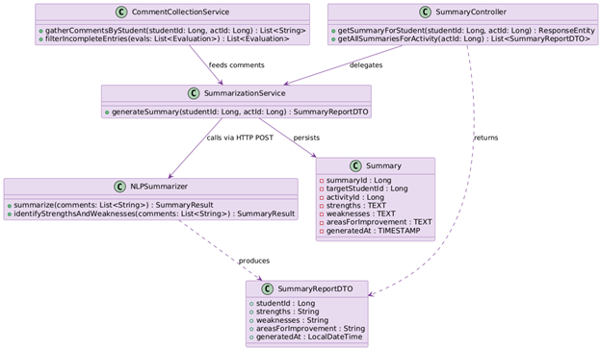

o Sequence Diagram

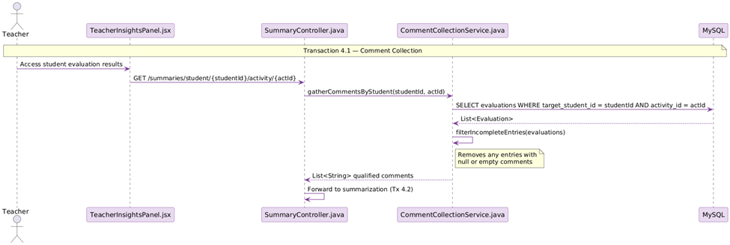
o ERD
Module 3.3 ERD - Comment Collection
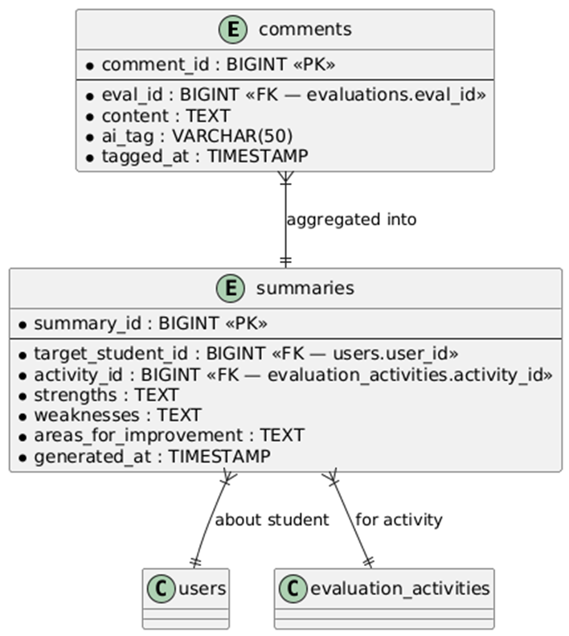

Module 4 - Student Management
Enables the teacher to manage the authorized student list by uploading an Excel (.xlsx) file. The system validates the file format, extracts student names and Gmail addresses, and stores them in the database. This list controls who can log in and how group members are displayed during evaluations.

4.1 Transaction: Student List (Teacher's Class Record)
The teacher uploads an Excel (.xlsx) file. The system validates whether the format is correct. If valid, the system extracts all student names and Gmail addresses from the file and stores them in the student_whitelist table, replacing any previously stored list.

- User Interface Design
- Front-end component(s)

Component Name | Description and Purpose | Component Type / Format
CreateActivityForm.jsx | Provides the teacher interface for uploading the student Excel file. Includes a file picker input restricted to .xlsx format, an upload button, and feedback on success or error. | React.js Component
activityService.js | Handles HTTP requests for uploading the Excel file (POST /students/upload) and exporting the current student list (GET /students/export). | JavaScript Service Module
ClassOverview.jsx | Displays the currently stored student list in a sortable table, showing student names and Gmail accounts. Allows teachers to verify the uploaded list before running evaluations. | React.js Component

- Back-end component(s)

Component Name | Description and Purpose | Component Type / Format
StudentController.java | Exposes REST endpoints for student list management: POST /students/upload (receive and process Excel file), GET /students/export (download current list as Excel). | Spring Boot REST Controller
ExcelParserService.java | Validates the uploaded .xlsx file format. Extracts student names and Gmail addresses from each row. Returns a List. Also supports exporting the current whitelist back to Excel format. | Spring Boot Service Class
StudentRecord.java | Plain Java class (POJO) representing one row from the Excel file: studentName (String) and gmail (String). | Java POJO
WhitelistRepository.java | JPA repository for CRUD operations on the student_whitelist table. Used by StudentController to replace the whitelist after each successful upload. | Spring Data JPA Repository

o Class Diagram
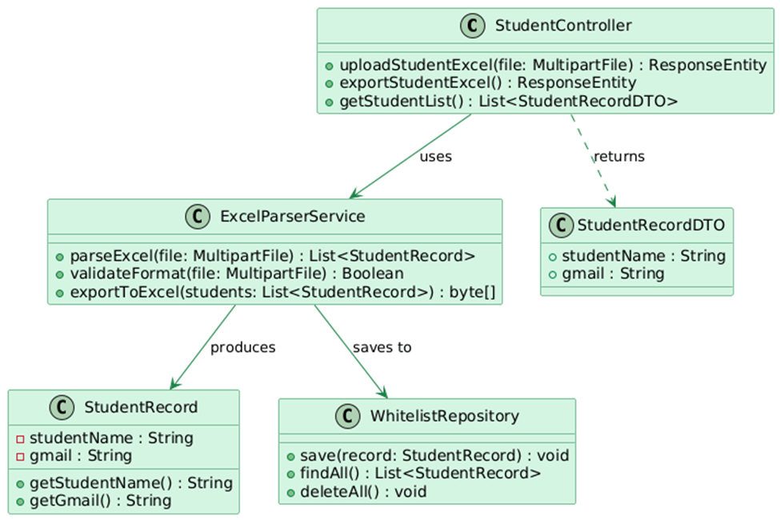

o Sequence Diagram

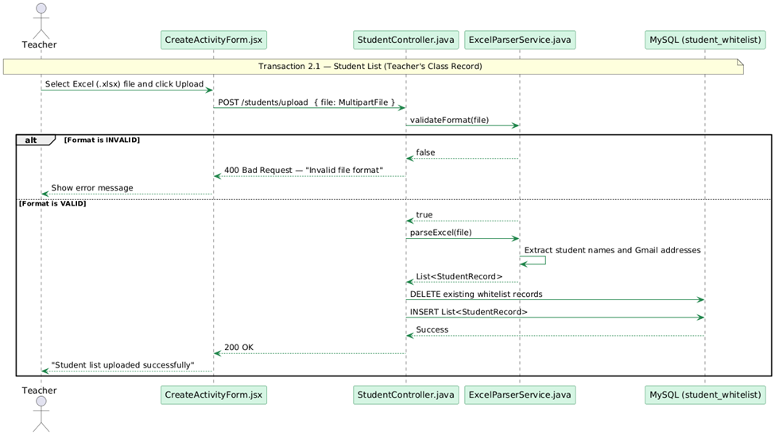
o ERD
Module 4.1 - Student List (Teacher's Class Record)
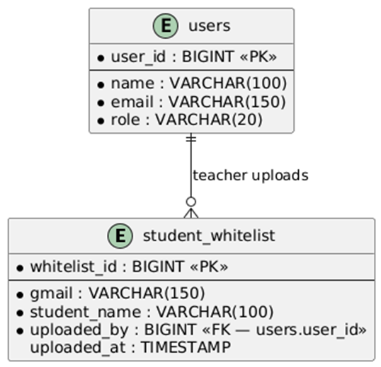

Module 5 - Self and Peer Evaluation
Covers the full evaluation lifecycle: teachers create evaluation sessions with rubrics and deadlines (3.1), and students submit scored peer evaluations with comments (3.2). Score validation rules enforced: scores must be between 0 and 10, and each member must receive a unique score within the same criterion. Students may evaluate themselves as part of the group.

5.1 Transaction: Create Evaluation Session
The teacher fills in the evaluation session details: title, rubric criteria (e.g., Participation, Cooperation, Leadership), and deadline. Upon submission, the system stores the activity and makes it accessible to all students in the whitelist.
- User Interface Design
- Front-end component(s)
Component Name | Description and Purpose | Component Type / Format
CreateActivityForm.jsx | Form where the teacher enters the activity title, selects or defines rubric criteria, and sets a deadline. On submit, sends the data to ActivityController. | React.js Component
activityService.js | Handles POST /activities/create to send the new evaluation session data to the backend. | JavaScript Service Module
- Back-end component(s)
Component Name | Description and Purpose | Component Type / Format
ActivityController.java | Receives POST requests to create a new evaluation activity. Validates the input DTO and delegates to the repository to persist the new EvaluationActivity record. | Spring Boot REST Controller
EvaluationActivity.java | Entity representing a peer evaluation event. Fields: activityId, title, deadline, isActive (Boolean), rubricCriteria (JSON list), createdByTeacherId. | Java Spring Boot Entity (MySQL Table: evaluation_activities)
ActivityDTO.java | Data Transfer Object for creating a new evaluation activity. Contains: title (String), rubricCriteria (List), deadline (LocalDateTime). | Java Spring Boot DTO
o Class Diagram
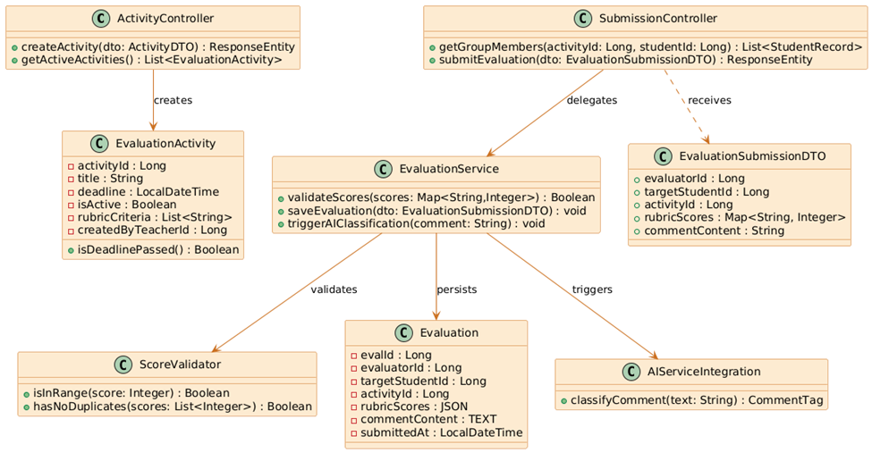
o Sequence Diagram

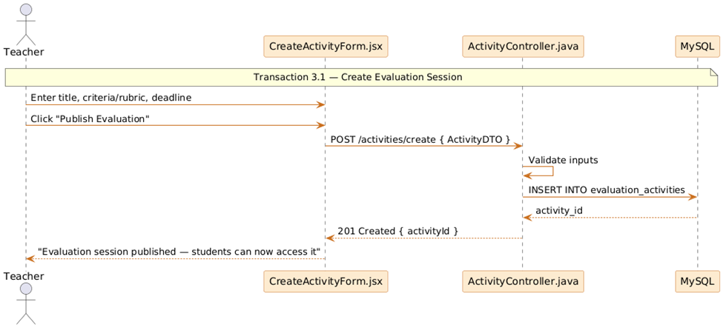

o Class Diagram
Module 5.2 - Create Evaluation Sessions
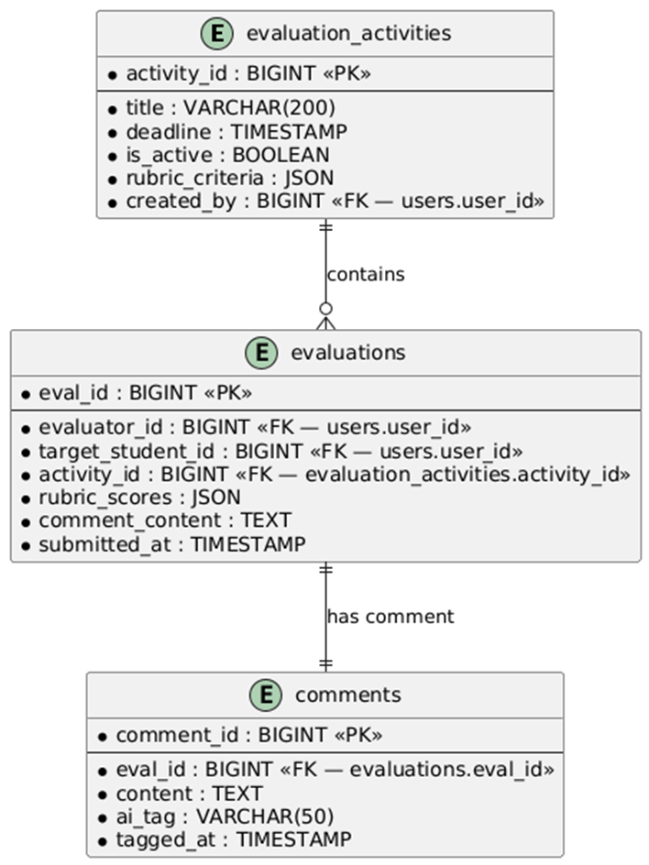

5.2 Transaction: Submit Peer Evaluation
The student views their assigned group members (listed in the order they appear in the uploaded Excel file, labeled Member 1, Member 2, etc.). The student assigns exactly one score per member per criterion. Scores must be between 0 and 10. Each member must receive a unique score within the same criterion — duplicate scores trigger an error and block submission. The student may include themselves in the evaluation. A written comment is submitted alongside the scores.

- User Interface Design
- Front-end component(s)
Component Name | Description and Purpose | Component Type / Format
EvaluationSubmissionView.jsx | Student-facing interface that lists all group members by their Excel order (Member 1, 2, 3...). Displays rubric criteria input fields for each member. Enforces minimum character count on comments. Shows real-time error if duplicate scores are detected within a criterion before allowing submission. | React.js Component
EvaluationForm.jsx | Sub-component for inputting scores and writing comments for a single group member. Validates score is between 0 and 10. | React.js Component
submissionService.js | Handles GET /activities/{id}/members to load group member list, and POST /evaluations/submit to send the completed evaluation. | JavaScript Service Module
- Back-end component(s)
Component Name | Description and Purpose | Component Type / Format
SubmissionController.java | Handles GET /activities/{id}/members (returns ordered member list from student_whitelist) and POST /evaluations/submit (receives EvaluationSubmissionDTO and delegates to EvaluationService). | Spring Boot REST Controller
EvaluationService.java | Core business logic for evaluation submission. Delegates score validation to ScoreValidator, then persists the Evaluation entity. After saving, triggers AIServiceIntegration to classify the comment. | Spring Boot Service Class
ScoreValidator.java | Validates all submission scores: (1) each score must be between 0 and 10 inclusive, (2) within each criterion, all scores assigned to different members must be unique. Returns a ValidationResult with any error messages. | Spring Boot Component
EvaluationSubmissionDTO.java | DTO encapsulating the student's submission. Fields: evaluatorId, targetStudentId, activityId, rubricScores (MapString, Integer> — criterion name to score), commentContent (String). | Java Spring Boot DTO
AIServiceIntegration.java | Sends the submitted comment text via HTTP POST to the Python Flask CommentClassifier microservice. Receives a tag (Constructive, Vague, or Off-topic) and persists it as a Comment entity. | Spring Boot Service Class
Evaluation.java | Entity representing one completed peer evaluation. Fields: evalId, evaluatorId, targetStudentId, activityId, rubricScores (JSON), commentContent (TEXT), submittedAt. | Java Spring Boot Entity (MySQL Table: evaluations)
Comment.java | Entity representing the peer comment associated with an evaluation. Fields: commentId, evalId, content, aiTag (Constructive/Vague/Off-topic), taggedAt. | Java Spring Boot Entity (MySQL Table: comments)
o Class Diagram



o Sequence Diagram

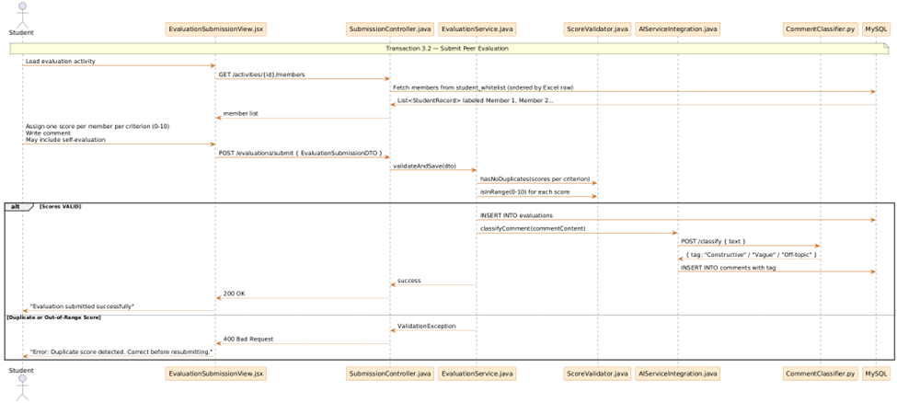

o ERD
Module 5.2 - Submit Peer Evaluation


